

**MISSOULA PUBLIC TREE INVENTORY REPORT**

**MISSOULA PARKS AND RECREATION**

September 30, 2013

Missoula Parks and Recreation Department

Operations Division

100 Hickory Street

Missoula, MT 59801

(406) 552-6277

[www.missoulaparks.org](http://www.missoulaparks.org)

**TABLE OF CONTENTS**

EXECUTIVE SUMMARYiii

GLOSSARYiv

1. INTRODUCTION1

1.1 Urban Forestry in Missoula1

1.2 Demonstrated Need 1

1.3 Census Objectives 2

1.4 Site Description 3

2. CENSUS METHDOLOGY 3

2.1 Preparation3

2.2 Inventory Protocols4

2.2 ArcGIS and TreeWorks Software Integration5

3. RESULTS 5

3.1 Census Summary5

3.1.1 Population Totals7

3.1.2 Species Composition and Diversity7

3.1.3 DBH Size Class8

3.1.4 Tree Condition Ratings9

3.1.5 Tree Risk Distribution10

3.1.6 Biotic Defects11

3.1.7 Structural Defects12

3.1.8 Cultural Defects13

3.1.9 Tree Maintenance Tasks15

3.1.10 Appraisal Values16

3.2 i-Tree Studies17

3.2.1 i-Tree Canopy18

3.2.2 i-Tree STREETS18

4. URBAN FORESTRY MANAGEMENT RECOMMENDATIONS AND STRATEGIES 19

REFERENCES21

APPENDIX A: Species Detail Distribution22

APPENDIX B: Results Maps26

APPENDIX C: i-Tree Benefits Lists34

**LIST OF FIGURES**

Figure Number Page

1. Area of 2013 Tree Census 6
2. Population Distribution of Missoula’s Most Abundant Tree Species7
3. Diameter at Breast Height (DBH) Distribution of Inventoried Trees8
4. Condition Distribution of Inventoried Trees9
5. Tree Risk Distribution10
6. Biotic Defect Distribution of Inventoried Trees 11
7. Structural Defect Distribution of Inventoried Trees 13
8. Cultural Defect Distribution of Inventoried Trees 14
9. Distribution of Maintenance Tasks Required for Inventoried Trees 16
10. TreeWorks Formula for Calculating Appraisal Values of Missoula’s Urban Forest 16
11. Distribution of Appraised Values for Missoula’s Urban Forest 17

**LIST OF TABLES**

Table Number Page

1. Top 20 Tree Species in Missoula, including Cultivars, by Percent and Count8

2. Distribution of Diameter Classes by Percent and Count9

3. Condition Distribution by Percent and Count10

4. Tree Risk Distribution by Percent and Count10

5. Biotic Defect Detail by Percent and Count12

6. Structural Defect Detail by Percent and Count13

7. Cultural Defect Detail by Percent and Count15

8. Distribution of Required Maintenance Tasks by Percent and Count16

9. Appraised Values of Missoula’s Urban Forest17

10. Estimated Percent Cover and Land Area of Cover Classes in Missoula18

**EXECUTIVE SUMMARY**

In 2012, the City of Missoula Department of Parks and Recreation, Urban Forestry Division (UF), received a grant from the Montana Department of Natural Resources and Conservation (DNRC), with funding from the U.S. Forest Service, to conduct a citywide tree resource assessment.

The inventory of Missoula’s right-of-way (ROW) trees was conducted in the summer of 2013 by Arborists and Research Specialists from the City’s Urban Forestry Division with a coalition of volunteers from the Trees for Missoula (TFM) non-profit. The City of Missoula encompasses about 27.51 square miles and contains residential, commercial, agricultural, and industrial developments. Approximately 74.23% of the public streets in Missoula were inventoried. Using the ArcGIS software suite and TreeWorks extension, a database was created that provides geographic information and tree-specific data. This database contains records of 20,545 trees, 305 stumps, and 234 planting sites.

The total appraised value of the City of Missoula’s urban forest is approximately $70.7 million.

**GLOSSARY**

**Arboriculture:** The art, science and technology of cultivating and maintaining trees, shrubs and other woody plants.

**Citizen Service Requests (CSRs):** Customer service reports generated by citizen callers pertaining to questions about tree health and maintenance requests.

**Chapter 12.32 Missoula Municipal Code:** the City of Missoula Ordinance Number 3043 describing tree, shrub, planting, pruning, and maintenance standards and regulations designed to protect the health, safety, and welfare of the public and the tree resource.

**Chlorosis:** A nutritional deficiency resulting in a yellowing of leaves due to a lack of chlorophyll.

**Diameter at Breast Height (DBH)**: the standard method of measuring the trunk diameter of a tree at 4.5 feet above ground.

**Geographic Information System** **(GIS)**: A system of computer hardware and software designed for the analysis, storage and mapping of geographic data. Data are stored as points, lines, polygons, raster images (pictures, aerial photographs, or 3D surfaces) and tables.

**Global Positioning System (GPS)**: A system of satellites and ground units used together to determine terrestrial location and elevation. The GPS receiver is able to communicate with satellites to determine precise spatial information for the user.

**Hazard:** imminent threat to the public and to infrastructure.

**i-Tree:** a public domain software suite developed by the U.S. Forest Service that offers tools for assessing, analyzing, and strengthening management of urban forests. i-Tree Canopy and i-Tree Streets were used to estimate Missoula’s canopy cover and to quantify benefits of street trees.

**Montana Department of Natural Resources and Conservation (DNRC):** the agency that provides leadership in managing Montana’s water, soil, forest, and rangeland resources. Grant funding for the Missoula public tree inventory was awarded by the DNRC.

**Park Tree:** all trees on city owned or leased land other than trees that are in the public right-of-way.

**Position Dilution of Precision (PDOP):** A relative figure used with GPS navigation to compare the error in user position and the error in satellite position. The lower the value, such as 1-3, means more precise data.

**Public Right of Way (ROW):** the width between the dedicated boundaries of all public streets, roads, boulevards, and alleys. This includes all sidewalks and public parking strips located within such boundaries.

**Senescence:** the natural aging process of the tree organism.

**Street/Boulevard Tree:** any tree which exists in an area of public right-of-way between the edge of the public roadway, whether curbed or not, and the private property line.

**Topping:** the cutting back to a stub or non-lateral branch within the tree’s crown to such a degree that removes the normal tree canopy and disfigures the tree.

**Trees for Missoula** **(TFM)**: A non-profit organization based in Missoula dedicated to the advocating of Missoula’s urban forest.

**Urban Canopy Cover (UTC):** the area covered by leaves, branches, and tree stems when viewed from aerial photographs, satellite imagery, or ground sampling.

**Urban Ecology:** A subfield of ecology which deals with the interaction between organisms in an urban or urbanized community, and their interaction with that community. In this perspective, the city itself is viewed as an ecosystem.

**Urban Forestry:** The art, science, and technology of planning and managing trees, greenspaces and forest resources in and around urban community ecosystems for the physiological, sociological, economic, and aesthetic benefits that trees provide society.

**Urban Forestry Division (UF):** Missoula’s Urban Forestry Division is dedicated to maintaining, enhancing, and expanding the urban forest through tree planting, pruning, and hazard removals.

**1. INTRODUCTION**

**1.1 Urban Forestry in Missoula**

The City of Missoula’s Department of Parks and Recreation Urban Forestry division is committed to providing responsible stewardship of over 25,000 right-of-way (ROW) trees and 5,500 City park trees. Urban Forestry provides for the establishment and maximization of healthy tree canopy coverage to provide a wide range of benefits including air quality, shade, carbon sequestration, enhanced property values, and habitat for wildlife.

Primary goals of Missoula’s Urban Forestry program are to assure public safety and to maximize and sustain the benefits produced by the forest resource. Additional goals include improvement of community wide aesthetics, minimization of infrastructure conflict and implementation of green infrastructure concepts, public outreach, and facilitation of recreation and leisure activities. Trees that are properly planted and maintained appreciate in value over time, thereby providing a significant public service. Collectively, the tree and shrub resource in Missoula improves the quality of life for residents and visitors.

The Urban Forestry Division, excluding the Greenways and Horticulture branch, has an established budget of over $353,000 to manage the publicly-owned forest resource. The staff includes a full-time Urban Forester, one full-time Lead Arborist, two ten-month seasonal Arborist Technicians, and several seasonal staff. Services include tree planting, pruning, hazard tree removal, stump grinding, inspections, monitoring, storm damage repair, and education. In 2012, the Division planted 105 trees, pruned 550 trees, and removed 123 dead or hazardous trees.

A variety of activities and projects are offered through the Forestry Division. The Memorial Tree program commemorates individuals by planting trees with memorial plaques in city parks. Second, homeowners may request the planting of boulevard trees by the Forestry Division through participation in the Cost Share program. Third, the Christmas Evergreen program collects cut trees after the holiday and recycles these into mulch, thereby generating a productive resource that reduces landfill waste. Last, the Run for the Trees fundraiser held each spring raises awareness and support for Missoula’s urban forest.

For 25 years, Missoula has been recognized as a “Tree City USA” community. Achieving this designation entails meeting urban forestry management standards set by the Arbor Day Foundation in cooperation with the National Association of State Foresters and U.S. Forest Service. This includes “establishment and utilization of a tree board or commission, a tree care ordinance, an operating budget for the forestry program of at least $2 per capita, and celebration of Arbor Day” (Arbor Day Foundation, 2013).

**1.2 Demonstrated Need**

In order to appropriately manage Missoula’s urban forest, the properties, condition, and extent of the resource must first be evaluated. A current forest assessment, accomplished through a complete public tree inventory, provides a comprehensive and statistically reliable accounting of the urban forest. This enables managers to make efficient decisions as well as plan for effective long-term management.

Prior to 2013, the City of Missoula’s Urban Forestry Division spearheaded three inventories of publicly-owned street trees. The first citywide inventory was launched in 1973, which provided the Division with operating information for 20 years. Between 1993 and 1996, a subsequent inventory catalogued and digitized the size, species composition, condition, maintenance requirements, and work history of approximately 11,000 trees.

In 2003, the Missoula tree inventory was expanded to include areas not previously inventoried and those recently annexed by the city. With funding awarded by the Montana Department of Natural Resources and Conservation (DNRC) via the U.S. Forest Service, a contractor was hired to re-inventory 12,868 trees and planting sites (10,468 and 2,400, respectively) within city-owned boulevards and right-of-way areas. The 1993 and 2003 inventories covered an area encompassing approximately 41.26% of Missoula’s public streets.

Effective management of the urban forest cannot be achieved when data is known from only a small portion of the City. Additionally, annexation and land acquisition continues to increase the total land area of Missoula, thereby extending the responsibility of the Urban Forestry Division to manage public trees. To this end, the Urban Forestry Division applied for and was awarded a DNRC Program Development Grant in 2012 to conduct an updated tree inventory. Grant funds had previously been awarded to purchase the tree management software TreeWorks, an ArcGIS extension developed by the Kenerson Group, and to convert the 2003 inventory database to the TreeWorks format. The Trees for Missoula (TFM) non-profit donated global positioning system (GPS) handheld equipment to record digital coordinates of each tree. Combined, these resources enabled an accurate and efficient accounting of the urban forest.

The 2013 census, the fourth citywide tree resource assessment, is a proactive approach to provide forestry staff and the public with current and complete information pertaining to the urban forest. This will assist in abating hazards to the public and to the city from a liability standpoint, while minimizing potential pest and disease risk to the forest resource. At multiple scales, (i.e., by tree, species, neighborhood, ward, and city), the tree inventory can suggest the value and role that Missoula’s urban forest plays in its community. The 2013 tree census will improve the Urban Forestry Division’s capacity to plan for and manage the future of Missoula’s urban forest.

**1.3 Census Objectives**

Missoula’s 2013 urban forest assessment is guided by the following goals:

1. Determine the extent of the public forest
2. Determine the age, diameter class, condition, and maintenance of the forest
3. Determine the areas in greatest need of maintenance
4. Anticipate where trees are nearing the end of their lifespan and will need to be replaced in the near future
5. Inform property owners and tax payers as to the economic, environmental, and personal benefits of trees

The Missoula tree census may serve as a model for other cities in Montana to follow in order to reach their own urban forestry goals.

**1.4 Site Description**

Situated in mountainous western Montana, Missoula County lies approximately 115 miles west of Helena, Montana’s capital city. The county seat is the City of Missoula, located at an elevation of 3200 feet. Missoula is located on the banks of the Clark Fork and Bitterroot Rivers and at the convergence of five mountain ranges. The City has four distinct seasons with an average temperature of 44.6° Fahrenheit (ranging from an average of 22.8°F in January to 67.5°F in July) and 13.61 inches of precipitation (Western Regional Climate Center, 2012).

The 2012 USDA Plant Hardiness Zone map, which defines regions by annual average minimum temperatures that can support certain trees and plants, classifies Missoula within Zone 5b (USDA Agricultural Research Service, 2012). The City of Missoula follows planting guidelines for Zone 4a due to late and early freezes, and isolated extreme freezing events, which are not usually associated with Zone 5.

Over 68,000 individuals inhabit the City of Missoula, for a population density of 2,427.6 people per square mile (U.S. Census Bureau, 2010). The total land area of the City is approximately 27.51 square miles; public streets comprise 311.78 linear miles.

Missoulians have a long history of supporting trees as a functional resource and an integral part of what make Missoula a great place to live and work. Known as the “Garden City”, Missoula received its name due to the abundant gardens and fruit trees planted near the turn of the last century. As Missoula was developed, fruit trees gave way to streets with residences and businesses. In the late 1890s to early 1900s, early settlers to Missoula paid to have trees moved across the continent from the East Coast via train and planted along the new city streets. In the present day, Missoula enjoys a legacy of iconic trees throughout many of its older neighborhoods, streets, parks, and trails. Norway maples (*Acer platanoides*) comprise an estimated 33.4% of this population. This even-aged monoculture has begun to decline due to natural senescence, periods of drought, and ongoing development in the City.

**2. CENSUS METHOLODOLOGY**

**2.1 Preparation**

Substantial planning and preparation was required to implement the tree inventory for the City of Missoula. Grant funding was secured from the DNRC in order to purchase the TreeWorks tree management software, translate the 2003 inventory database into this ArcGIS extension software, and fund two Research Specialists. Consultations with University of Montana faculty and DNRC staff were instrumental in the project’s design.

City of Missoula Arborists identified inventory zones based on criteria including residential neighborhoods and population density. Boundary lines were delineated on a City map at major streets, intersections, and railroad tracks. Next, maps were compiled from GIS shapefiles downloaded from the City of Missoula’s Geographic Information System (GIS) server. Inventory polygons were drawn in ArcGIS and used to chart completion progress throughout the duration of the project. At the outset, nine census zones radiating from the center of the City were created. Additional zones were identified as the census progressed – 42 zones were inventoried by three teams in 14 weeks.

The Trees for Missoula (TFM) non-profit was a key partner throughout the duration of the tree census project. TFM seeks to support and promote a healthy urban forest through advocacy, volunteerism, education, and outreach (TFM, 2013). Accordingly, TFM recruited volunteers to increase public awareness of the tree census objectives and the community forest. These volunteers were essential for providing matching funds for the DNRC grant. Volunteers participated in a training session prior to the commencement of the inventory. This training familiarized volunteers with informational resources that would accompany each census team for the purpose of educating the public.

TFM collaborated with Parks and Recreation to acquire one Trimble® GeoExplorer 6000 series handheld computer and three Trimble® Juno 5B series handheld computers for the community tree inventory. Each handheld computer was loaded with the mobile component of the TreeWorks and ArcPad programs. A half-day in the field was allocated for Urban Forestry staff to practice entering tree and management data into TreeWorks.

**2.2 Inventory Protocols**

The City street tree inventory was conducted for 14 weeks between June and September, 2013. All trees were inventoried in the public right-of-ways (ROW) within each of the 42 zones. ROWs were determined by referencing a City of Missoula-Sanitary and Storm Sewers map. This map was overlain on aerial images, allowing for the measurement of street widths and the differentiation between public and private trees. Park trees located along boulevards were included in the inventory; interior park trees will be inventoried at a later date.

Three census teams collected spatial and tree-specific data for inclusion in the City’s tree inventory database, in addition to updating the information collected during the 2003 tree inventory. Each of the three teams was led by a City of Missoula Arborist – two of these were paired with a Research Specialist. The third Arborist was responsible for logging data as well as assessing each tree. TFM volunteers accompanied the inventory for half or full day shifts. Each team was equipped with a handheld computer, a Diameter at Breast Height (DBH) tape, and a folder of information compiled by TFM. A measuring wheel proved to be useful in zones absent of boulevards delineating ROWs.

In each zone, census teams walked the length of public streets. A U-shaped walking path ensured that trees on side streets were assessed. Upon locating a public tree, its latitude and longitude coordinates would be computed and recorded by global positioning satellites. To maximize precision, this required consideration of the number of visible satellites, satellite stability, and Position Dilution of Precision (PDOP). A lower PDOP value indicated a more accurate GPS location based on satellite position – the goal was a PDOP value of three feet or less.

Arborists or volunteers measured the DBH of each tree; height, spread, and age were not assessed due to time constraints. Arborists then identified tree species, defects, condition, risk, maintenance tasks, and maintenance priorities. Research Specialists entered tree data and address-specific attributes (for example, lot location, utility concerns, irrigation systems) into the TreeWorks mobile interface. Where applicable, tree stumps in need of removal and potential planting sites were recorded. TFM volunteers engaged interested residents and business owners, provided information on the project, and assisted in data collection.

**2.3 ArcGIS and TreeWorks Software Integration**

The ArcGIS software suite enables data to be stored, queried, analyzed, manipulated, and visualized spatially. The tree inventory data is stored in a separate database managed by the TreeWorks system. Prior to each inventory session, data pertinent to specific zones were downloaded to the handhelds. TreeWorks enables this data to be synced to the master database. Data points were checked back in to the master TreeWorks database daily, and displayed on a map compiled from City of Missoula shapefiles. Research Specialists managed this database and the check-in/check-out process.

TreeWorks enables users to query and review any tree in the inventory database. This is particularly useful for public relations and responding to specific questions from citizen callers. TreeWorks can also generate summary statistics from the inventory data, query specific attributes (such as tasks and safety risks), create work orders, calculate tree appraisals, and expedite response to Citizen Service Requests (CSRs). In sum, this computerized system promotes work efficiency and reliability.

**3. RESULTS**

**3.1 Census Summary**

Between June and September 2013, the public tree inventory was conducted along approximately 74.23% of Missoula’s city streets and boulevards (Figure 1). This inventory assessed 20,545 trees located in the City’s right-of-way. The average condition for inventoried trees is between poor to fair condition (a rating of 64.61). The average DBH is 11.8 inches.

Volunteers from the Trees for Missoula (TFM) non-profit were a valuable resource for acquiring information on tree diameters, addresses, and other site-specific attributes. Volunteers also provided information to homeowners and passersby, thereby maintaining survey continuity. A total of 24 volunteers contributed over 600 hours toward the inventory and toward grant matching funds.

The ratio of the City’s population to *inventoried* street trees is about 3:1. Citywide, the tree canopy is estimated to cover 9.6% of Missoula’s total land area (Table 10).

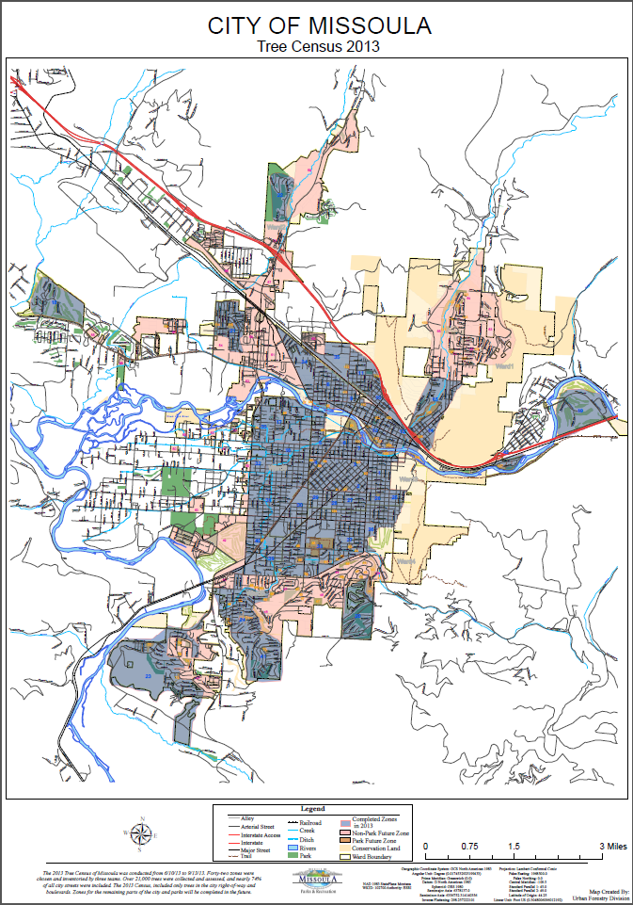

Figure 1: Area of 2013 Tree Census

*3.1.1 Population Totals.* The completed tree resource assessment included 20,545 public trees, 305 stumps, and 234 planting sites located within the city’s ROW.

*3.1.2 Species Composition and Diversity.* Norway maples (*Acer platanoides*) accounted for 33.4% of the total street tree population (Figure 2, Table 1). This total includes the Crimson King, Schwedler, and Emerald Queen cultivars (numbers 14, 19, and 91 in the order of total abundance, Appendix A). Previous estimates, including the 2003 Missoula tree census, suggested this species comprised about 60% of the public tree resource. Relative composition has declined due to city annexation, new developments, an expanded tree census area, and tree removals commensurate with natural senescence.

Maple species, taken in whole, comprise 43.6% of the total inventoried tree population. Species of the ash (*Fraxinus*) genus cover 12.1% of Missoula’s inventoried trees. Collectively, the maple and ash genus comprise 55.7% of the surveyed urban forest. The five most abundant species in Missoula (Figure 1), with respective cultivars included, make up 55.9% of Missoula’s canopy. The remaining 44.1% of species in Missoula are fairly diverse – a goal of UF per Chapter 12.32 of Missoula’s Municipal Code.

Clusters of monocultures exist in certain neighborhoods and zones (Appendix B, pg. 26). For example, 73.4% of Missoula’s downtown trees are Honeylocusts (*Gleditsia triacanthos*). Similarly, the majority of ROW trees in the University District are Norway maples. Since biodiversity may lead to stability, monoculture neighborhoods should be monitored closely for disturbance.

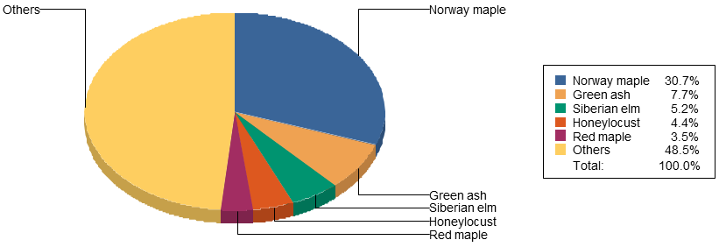

Figure 2: Population Distribution of Missoula's Most Abundant Tree Species

Table 1: Top 20 Tree Species in Missoula, including Cultivars, by Percent and Count

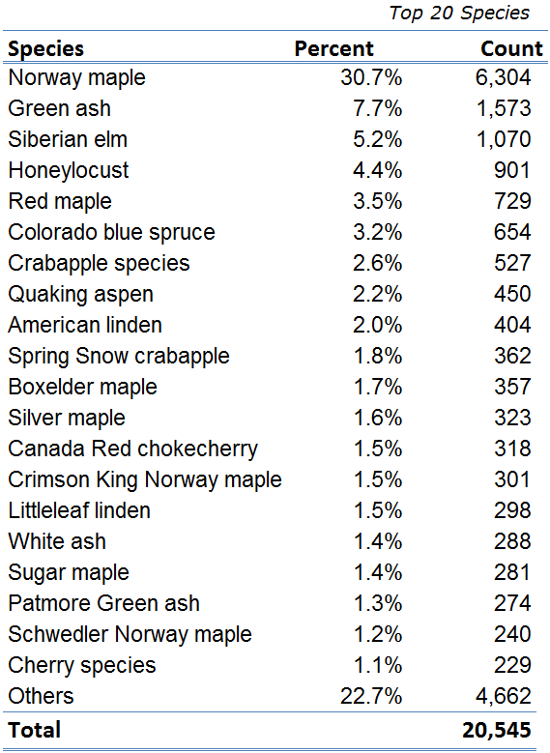

*3.1.3 DBH Size Class.* The average DBH size class for all public trees inventoried in the City is 11.8 inches. Since DBH is a good indicator of age, the data indicate that there is a lack of diversity in both age and size of Missoula’s urban forest. The majority of trees are 12 inches or under; few are over 30 inches, which is considered a large tree for Missoula.

Clusters of even-aged trees are particularly salient in areas such as the University District and new developments (Appendix B, pg. 27 & 28). An ideal forest structure would contain trees evenly distributed across all size classes. Similar to species diversity, age diversity is important because it promotes forest stand stability, resistance to disturbance (such as irruptive pest outbreaks, disease, and climatic variability), and resilience after a disturbance. This diversity reduces the likelihood of losing an even-aged cohort in a short time period.

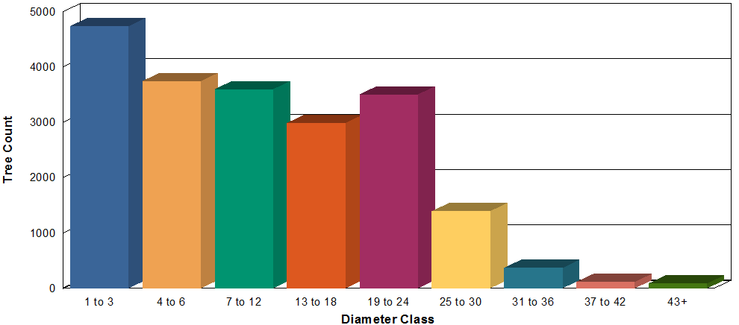

Figure 3: Diameter at Breast Height (DBH) Distribution of Inventoried Trees

Table 2: Distribution of Diameter Classes by Percent and Count

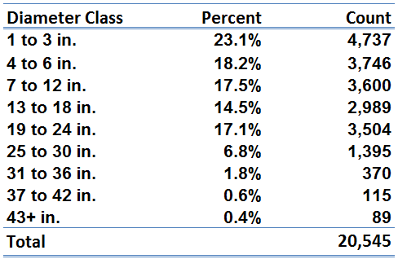

*3.1.4 Tree Condition Ratings.* Trees were assigned a condition rating from 0 (dead) – 100% (excellent). These conditions were defined as follows:

* Excellent (90+): Tree structure is appropriate to species type and physiology, with few if any structural defects.
* Good (80-89): Few structural defects, not topped, no dieback, and minimal deadwood. Structural defects, i.e. deadwood, can be solved through pruning.
* Fair (70-79): Tree is in accordance with natural senescence, not topped, and may have some structural defects that may not be fixable through pruning.
* Poor (50-69): Tree has had numerous structural or cultural defects – pruning will not improve the condition rating. Tree is topped, with minor dieback at 30-50%.
* Very poor (30-49): Tree has major dieback, multiple hazards, and is less than 50% alive. Very poor trees tend to be removals or approaching removal territory.
* Dead (0-29): 10% or less live woody tissue. Tree should be removed.

The average condition of trees in this inventory is 64.6 (Appendix B, pg. 29 & 30). This corresponds with a fair to poor rating, yet is much closer fair. In general, trees with a smaller DBH have a better average condition, since any structural defects they may have can be abated with pruning. Tree training, proper care, and maintenance are key to a healthy future.

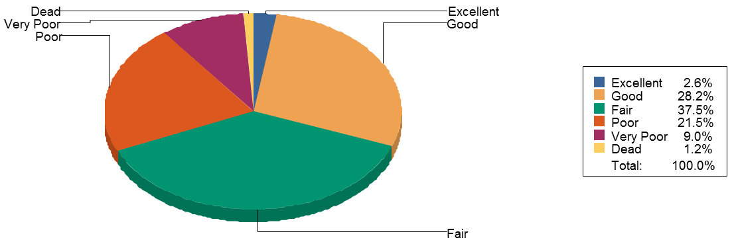

Figure 4: Condition Distribution of Inventoried Trees

Table 3: Condition Distribution by Percent and Count

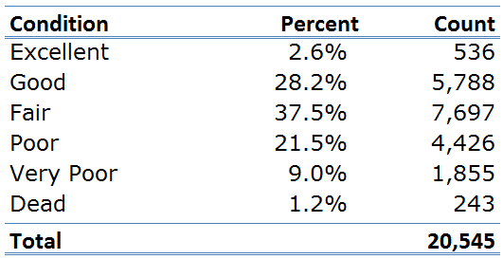

*3.1.5 Tree Risk Distribution.* Tree risk is defined as the likelihood of failure of a whole tree or its parts. Tree failure can result from broken stems, limbs, or a loss of support from root systems (Tree Care Industry Association, Inc., 2011). A risk assessment was performed on each tree in this inventory. It is important to note that a hazard rating does not affect a tree’s condition rating.

94.6% of Missoula’s inventoried public trees have very low risk. This vast majority poses minimal hazard to people or property. For trees that have low risk to whole or part, pruning of hangers or removal of dead limbs may easily reduce the risk rating. Trees that have moderate, high, or extreme risk have been placed on a priority list for maintenance or removal by either City of Missoula Arborists or private contractors.

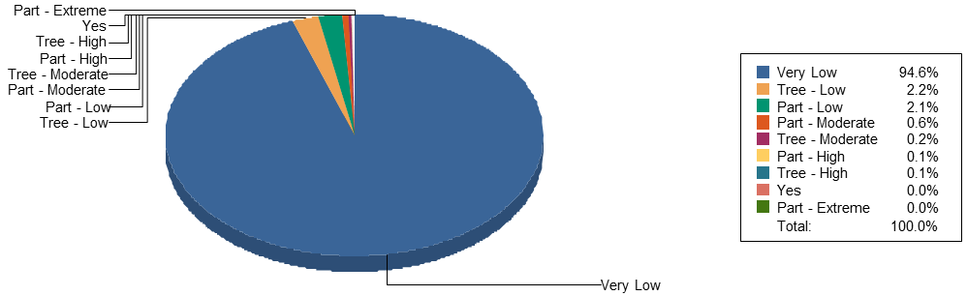

Figure 5: Tree Risk Distribution

Table 4: Tree Risk Distribution by Percent and Count

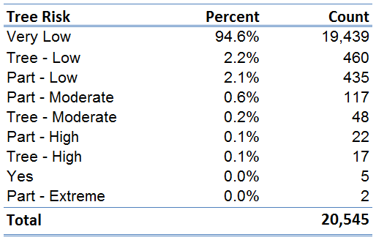

*3.1.6 Biotic Defects.* Tree defects are categorized as originating from either a biotic, structural, or cultural source. Multiple trees in this inventory have more than one defect, which in turn determines condition rating. Trees in excellent condition are generally devoid of defects.

The presence and visible effects of insects accounted for 71.6% of the top 5 identified biotic defects (this list includes aphids, poplar borer, and insect families defined by their practice of eating the leaves they roll around themselves for protection). This baseline data can be used to monitor changes in the composition, abundance, and effects of insect populations over time. This is important because severe pest outbreaks have the potential to lead to defoliation, branch dieback, and tree stress. Stressed trees may be more susceptible to attack by other pests and disease. Monitoring is particularly important in anticipation of the spread of highly destructive pests such as the Emerald Ash Borer beetle, which has yet to reach Montana’s borders.

Wildlife damage was detected on 11.8% of inventoried trees. Herbivory and damage to tree bark by ungulates accounted for much of this damage. Damage from squirrels was identified by flattened tree limbs due to the stripping of bark to get to the vascular cambium for sustenance. Beaver damage was the third most common defect attributed to wildlife.

Iron chlorosis is associated with 6.6% of Missoula’s inventoried trees. A chlorotic tree is unable to uptake nutrients, in part attributed to factors such as salt damage, soil pH, and soil compaction. This nutrient deficiency results in the yellowing of leaves due to a lack of chlorophyll. In more severe cases, leaf edges may scorch and turn brown. Chlorosis reduces health and condition, and may eventually cause individual limbs or trees to perish.

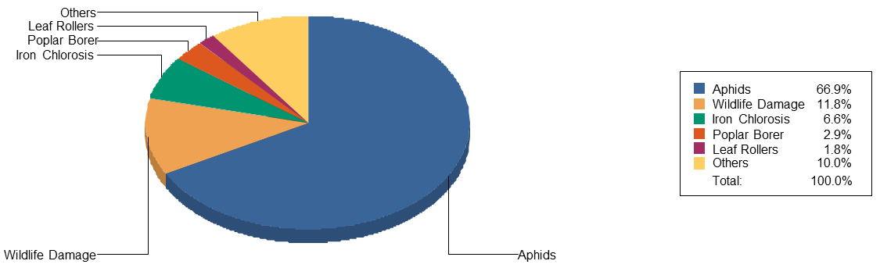

Figure 6: Biotic Defect Distribution of Inventoried Trees

Table 5: Biotic Defect Detail by Percent and Count

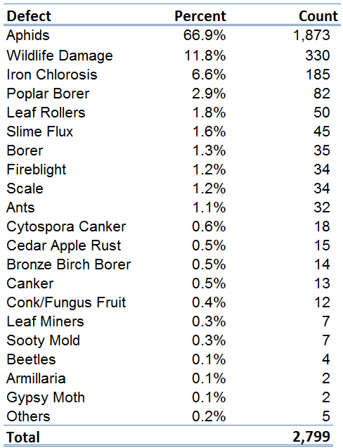

*3.1.7 Structural Defects.* Structural defects describe features or deformities in either a whole tree or its parts that may result in weak structure. In more severe cases, structural defects can lead to tree failure (Tree Care Industry Association, Inc., 2011).

Deadwood describes naturally occurring death of tissue dispersed evenly throughout a tree (23.8%, Figure 7, Table 6). Minor dieback is deadwood in a concentrated area, which usually leads back to one larger parent stem (10.0%). Major dieback describes this occurrence in multiple concentrated areas and multiple parent stems (7.8%).

Trunk scars describe lesions in the tree’s bark layer which expose living tissue and create an opening for pathogens. In Missoula, trunk scars most commonly originate from damage caused by storms, ungulates, and vehicles. Branch architecture becomes a defect when the tree has not received crown training for proper growth. Visible indicators include fused and crossing branches as well as sucker growth.

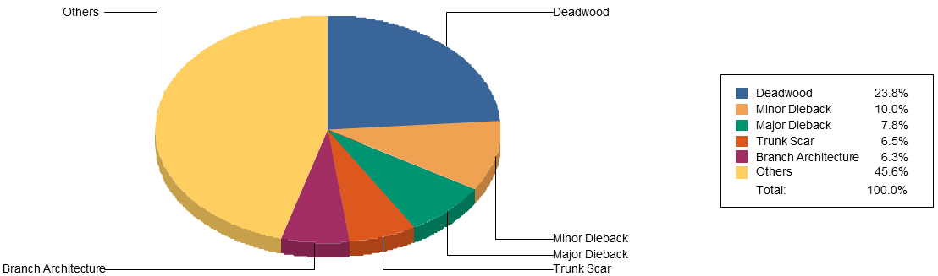

Figure 7: Structural Defect Distribution of Inventoried Trees

Table 6: Structural Defect Detail by Percent and Count

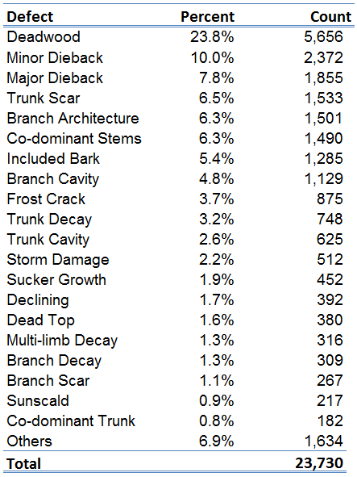

*3.1.8 Cultural Defects.* In this tree inventory, cultural defects describe misguided attempts to plant trees or provide tree care. Topping and improper pruning account for 30.2% and 10.1% of the top five cultural defects. A topped tree has been disfigured due to the cutting back of its crown to a stub or non-lateral branch. This method has been practiced based on the conception that topping will promote growth and prevent tree danger by reducing height. In reality, topping results in a hazardous tree with splayed growth. UF created an “anti-topping” program in the early 1990s to increase public education and discourage further use of this method.

Improper pruning includes the practice of topping trees. In this inventory, improper prunes also describe flush cuts and cuts leaving behind stubs. A proper cut should follow the branch collar, without cutting into this tissue between the main stem and the branch.

Planting defects were also prevalent in this inventory. Trees planted too close (10.7%) could in part be described by “volunteer sprouts”, or seedlings sprouting near the parent tree. Otherwise, this defect describes inadequate spacing for intentional plantings. Under current municipal codes, a small tree requires a boulevard width of three feet and spacing of at least 20 feet between trees. For medium trees, boulevard widths should be seven feet or wider with 30 foot spacing. Large trees require boulevard widths of at least 10 feet with 40 foot spacing between trees. A tree planted too deep lacks an exposed root collar, which suffocates the roots.

The fifth most common cultural defect is a lack of water stress, which results in leaf scorch. Drought stress is a common issue in Missoula.

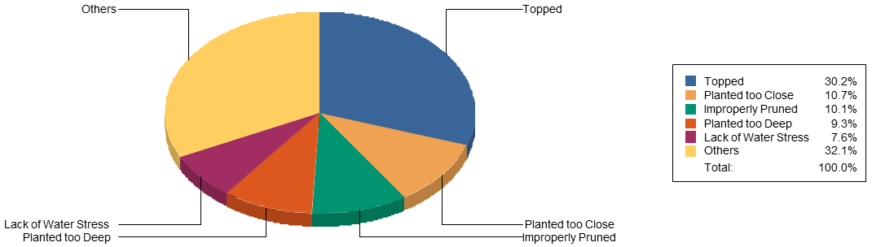

Figure 8: Cultural Defect Distribution of Inventoried Trees

Table 7: Cultural Defect Detail by Percent and Count

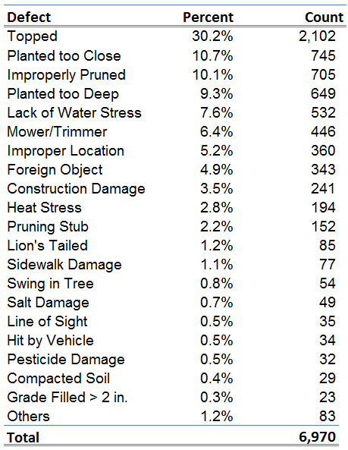

*3.1.9 Maintenance Tasks.* 73.9% of Missoula’s inventoried public trees are in need of pruning. Pruning tasks were differentiated as crown cleaning, crown training, and crown raising (Appendix B, pg. 31). Crown cleaning improves the health and lifespan of trees by removing deadwood, dieback and other structural defects. Crown training of small, young trees removes potential structural risk and promotes healthy growth. Crown raising entails removing lower limbs for building clearance or line of sight obstructions.

The 18.6% of trees that did not require maintenance were either too small to prune, were in fair to excellent condition, or conversely had declined past the point of intervention and would soon become removals. Tree removals and stumps removals comprised 5.5% and 1.3% of the inventoried population, respectively. Replanting of trees does not necessarily follow tree or stump removal, as planting is contingent in part on supply, homeowner preference, available growing space, and utility and/or line of sight conflicts.

In Table 8, the “enlarge” task refers to the need to modify tree grates so as to accommodate the diameter of the planted tree.

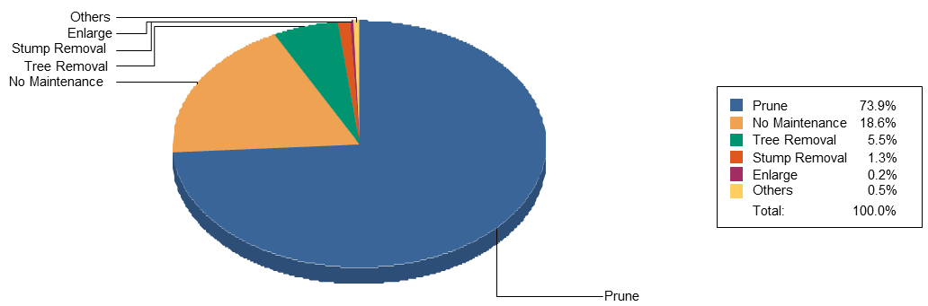

Figure 9: Distribution of Maintenance Tasks Required for Inventoried Trees

Table 8: Distribution of Required Maintenance Tasks by Count and Percent

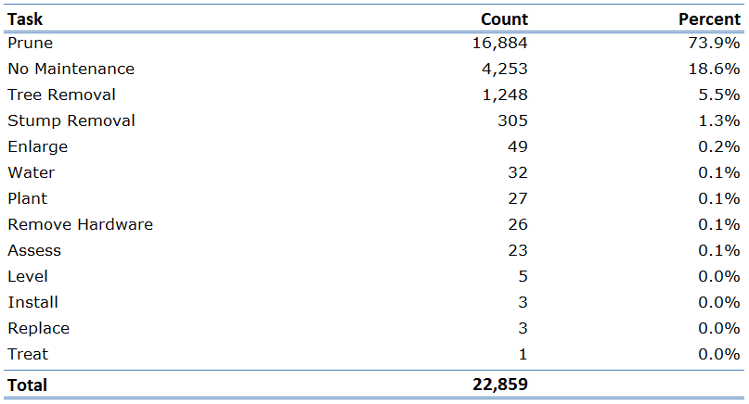

*3.1.10 Value/appraisals:* TreeWorks applies the following equation to each tree to appraise the overall value of Missoula’s urban forest:

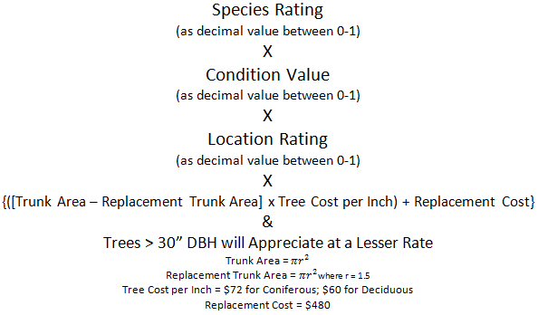

Figure 10: TreeWorks Formula for Calculating Appraisal Values of Missoula’s Urban Forest

A limitation of this appraisal applies to the location rating variable. In this census, a constant value of 75% was maintained for each tree, which was the pre-specified default. Since this rating was not customized, the appraisal values are likely an overestimation of the true value of the inventoried urban forest (Appendix B, pg. 32 & 33).

Most of UF’s resources are allocated toward pruning hazards and reducing liability of older trees. These trees tend to be in poor condition with unfixable defects. Small tree training, on the other hand, can fix structural defects and maintain the good health of these trees as they age. By improving tree condition, appraisal values are raised, therefore increasing the overall value of the urban forest.

Table 9: Appraised Values of Missoula's Urban Forest

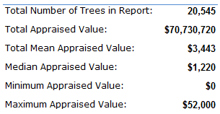

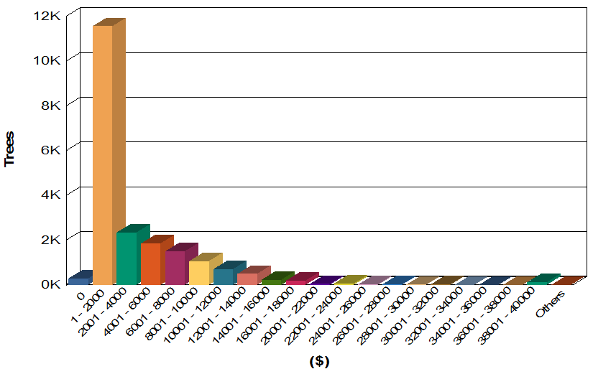

Figure 11: Distribution of Appraised Values for Missoula’s Urban Forest

**3.2 i-Tree Studies**

As the City of Missoula continues to experience human population growth and development, the community forest’s extent and structure similarly will be affected. Using i-Tree Canopy and i-Tree Streets, analyses were performed to assess current canopy cover and quantify benefits that trees bring to the City. i-Tree is a public domain software suite developed by the U.S. Forest Service that offers tools for assessing, analyzing, and strengthening management of urban forests (www.itreetools.org). Baseline results could be used to plan for future management, to identify trends as development progresses, and to communicate the value of the urban forest to the public.

**3.2.1 i-Tree Canopy**

Urban Canopy Cover (UTC) refers to the area covered by leaves, branches, and tree stems when viewed from aerial photographs, satellite imagery, or ground sampling. i-Tree Canopy was used to evaluate existing canopy cover throughout Missoula city limits. This free photographic interpretation tool generates random points onto Google Maps ™ images. Each point is then classified by the user into a pre-specified cover class. i-Tree processes each pixel of the aerial photograph and categorizes the pixel based on the classification of each point to generate overall cover results. These results can be used to benchmark loss or gain of canopy cover, and to determine tree planting objectives.

In this analysis, 1000 points were randomly generated within the City of Missoula, an area spanning 27.51 mi2. Public and private trees were not differentiated. In Table 10, *non-tree vegetation* includes shrubs, herbaceous vegetation, and grasslands. *Bare soil* is used to describe pervious sites such as gravel and construction sites with exposed soil. Points classified as *impervious other* include those landing on tennis courts and track fields.

Table 10: Estimated Percent Cover and Land Area of Cover Classes in Missoula

|  |  |  |
| --- | --- | --- |
| Cover Class | % Cover  (± SE*) | Land Cover**  (mi² ± SE) |
| Tree | 9.60 ±0.93 | 2.79 ±0.27 |
| Non-tree vegetation | 37.8 ±1.53 | 11.0 ±0.45 |
| Turf grass | 19.0 ±1.24 | 5.52 ±0.36 |
| Bare Soil | 6.80 ±0.80 | 1.97 ±0.23 |
| Water | 1.10 ±0.33 | 0.32 ±0.10 |
| Impervious road | 16.7 ±1.18 | 4.85 ±0.34 |
| Impervious building | 8.80 ±0.90 | 2.56 ±0.26 |
| Impervious other | 0.20 ±0.14 | 0.06 ±0.04 |
| * SE = standard error, or statistical estimate of uncertainty  **Total land area of the City of Missoula = 27.51 mi2 | | |

**3.2.2 i-Tree Streets**

i-Tree Streets was used to assess and quantify annual environmental benefits of Missoula’s urban forest. The model considers annual expenditures in order to estimate net benefits provided by the public tree resource.

i-Tree Streets allows the user to customize specific data fields based on the desired analyses. Species, DBH, land use, and utility data from the 2013 inventory were imported into the i-Tree Streets program. For the City of Missoula, specifications were entered as to the total municipal budget, population, total land area, total linear miles of streets, average sidewalk width, and average street width. The annual budget for the Urban Forestry Division was delineated into expenditures for planting, pruning, tree and stump removal, irrigation, program administration, CSRs, and other costs.

Estimated annual benefits of Missoula’s inventoried street trees are reported in terms of energy, stormwater, air quality, carbon dioxide, aesthetic values, and replacement values. Summary reports can be found in Appendix C.

**4. URBAN FORESTRY MANAGEMENT RECOMMENDATIONS AND STRATEGIES**

The 2013 street tree inventory enables an understanding of the current condition of Missoula’s dynamic urban forest. The baseline data generated from this census can be used to forecast trends, anticipate maintenance needs, develop planting decisions, and create budgets. The intent is to help inform the UF plan as to what is needed for the long-term sustainability, protection, restoration, and management of the tree resource, thereby ensuring its longevity for future generations.

One of the most immediate benefits from this inventory is that 118 priority tree removals were identified. Those posing high risk from whole or part were also flagged. These trees have already been placed on a contract list and will be removed from the population shortly. The tree census expedited this process, alerting UF of risk sooner than likely would have been noticed and reported otherwise. Public safety is a leading priority for Missoula Parks and Recreation and indeed, any public agency. The tree inventory has and can continue to reduce potential risks to citizens, private property, public property, and right-of-ways.

In addition to risk reduction, the tree inventory can be used to increase efficiency and effective allocation of resources. For example, maintenance assessments were made for each tree in the inventory. Each task received a priority rating, on a five-level scale from routine to low, medium, high priority or immediate action. The TreeWorks database can be used to determine and schedule where priority maintenance is required. Similarly, the database can be used to cross-reference service requests from citizens, therefore limiting driving mileage and staff time for evaluating each request.

The 2013 tree census helped to identify several trends and subsequently shape the following recommendations:

* *Continue to allocate resources toward the Missoula tree inventory.* Missoula’s urban forest is not static, and neither should be its public tree inventory. At present, the tree inventory covers an area equivalent to about 74.23% of Missoula’s public streets. Additional zones have been identified and delineated in ArcGIS that would bring the inventory total closer to 100%. These areas include park interiors, less populated residential districts, and industrial zones with few trees. Continuous assessment and completion of inventory zones could occur over the course of several years, even if only a few hours were dedicated each month. Each time any maintenance task or tree planting is completed, the database should be updated to reflect these changes.
* *Reduce lag time between public tree inventories.* Tree inventories in Missoula have been conducted in 1973, 1993, 2003, and 2013. The current inventory represents the most complete assessment yet of the urban forest. However, even with the TreeWorks resource, this inventory will not provide a true reflection of the state of the urban forest in a decade – the inventory lag time for the last 20 years. City annexation, urban development, planting/pruning actions by citizens, insect infestations, volunteer tree sprouts, and a changing climate are among many factors that will continue to affect the structure and stability of the urban forest. A lag period of 10 years between complete tree assessments is not sufficient to keep pace with the complex forest and its inter-relations with public infrastructure, people, and environment.
* *Increase pruning cycle to every 5-7 years.* With three Certified Arborists on staff at the City of Missoula’s UF Division, the current pruning cycle is estimated to be about every 47 years. Charged with maintaining over 20,500 street trees and 5,500 park trees, this inevitably leads to a reactive approach focused on reducing hazards and risk. An increased capacity for preventative maintenance would reduce storm damage risks from wind, heavy wet snow, and hanging limbs. It could also reduce risk from non-storm emergencies, such as conflicts with overhead and underground utilities, line of sight obstructions for signage and traffic lights, heaved sidewalks, and building clearance. Life expectancy and maintenance needs vary between species, with management ultimately affecting stability. Increased monetary and human resources could help improve and perpetuate the health, longevity, and aesthetics of Missoula’s urban forest.
* *Dedicate an UF crew to small tree training*. The 2013 tree inventory revealed that Missoula Municipal Code 12.32 is not being adhered to in terms of new planting sites. That is, newly planted trees are not being pruned for structure as they should. When the tree is small, Certified Arborists are able to make structural pruning cuts that improve the health of the tree as well as overall structural strength. Defects can be removed that would otherwise create unfixable hazards as the tree ages. The benefits are immediate and cost less the sooner action is taken.
* *Increase species diversity and age.* Species in the maple and ash genus currently represent 55.7% of Missoula’s urban forest. A stable and diverse tree population on the whole is better equipped to be resistant and resilient to biological pressures, such as insect and disease threats. As the aging tree population in Missoula is removed, it should be replaced with a population diverse in both species and age. Replacement of boulevard trees adjacent to private properties is already a priority for Urban Forestry, as these trees improve property values and aesthetics while reducing energy consumption. Missoula Municipal Code 12.32 states that 10-15% tree diversity needs to be maintained. UF and City Development Services, in particular, should improve communication regarding species and age class diversity of tree plantings in subdivisions as well as planting specifications, such as proper planting depth (ANSI z.133 Planting Specifications).
* *Increase public support and encourage participatory planning.* The TFM non-profit and Missoula Parks and Recreation collaborated successfully to plan and implement the tree inventory. TFM is guided in part by a mission to use education and outreach to garner support and donations on behalf of Missoula’s urban forest. Further support for mutual objectives could be raised through the dissemination of summary data and GIS maps from this tree inventory. This could be accomplished through press releases, public presentations, and information pages on the TFM website. Further, as census data is used to create a plan for the future of the urban forest, Missoula citizens could be encouraged to submit public comment. A public attitudes survey toward the forest could also be administered, including the collection of “visions” that residents may have for its future. The hope is that the publicity generated from the 2013 census will increase membership for TFM, and therefore support of the community tree resource.

**REFERENCES**

Arbor Day Foundation. 2013. Tree City USA®. <<http://www.arborday.org/programs/treecityusa/?breadcrumb=homepage>> (accessed 9/26/2013).

i-Tree. 2013. What is i-Tree? <<http://www.itreetools.org/index.php>> (accessed 9/18/2013).

Tree Care Industry Association, Inc. 2011. ANSI A300 (Part 9). American National Standard for Tree Care Operations – Tree, Shrub, and Other Woody Plant Management – Standard Practices (Tree Risk Assessment a. Tree Structure Assessment). Londonderry, NH.

Trees for Missoula. 2013. About. < <http://treesformissoula.org/about/>> (accessed 9/16/2013).

United States Census Bureau. 2010. State & County QuickFacts. <<http://quickfacts.census.gov/qfd/states/30/3050200.html>> (accessed 9/16/2013).

United States Department of Agriculture – Agricultural Research Service. 2012. USDA Plant Hardiness Zone Map. <<http://planthardiness.ars.usda.gov/PHZMWeb/>> (accessed 9/16/2013).

Western Regional Climate Center. 2012. General Climate Summary Tables: Missoula WSO AP, Montana: 1948-2012. <<http://www.wrcc.dri.edu/cgi-bin/cliMAIN.pl?mt5745>> (accessed 9/16/2013).

Appendix A: Species Detail Distribution

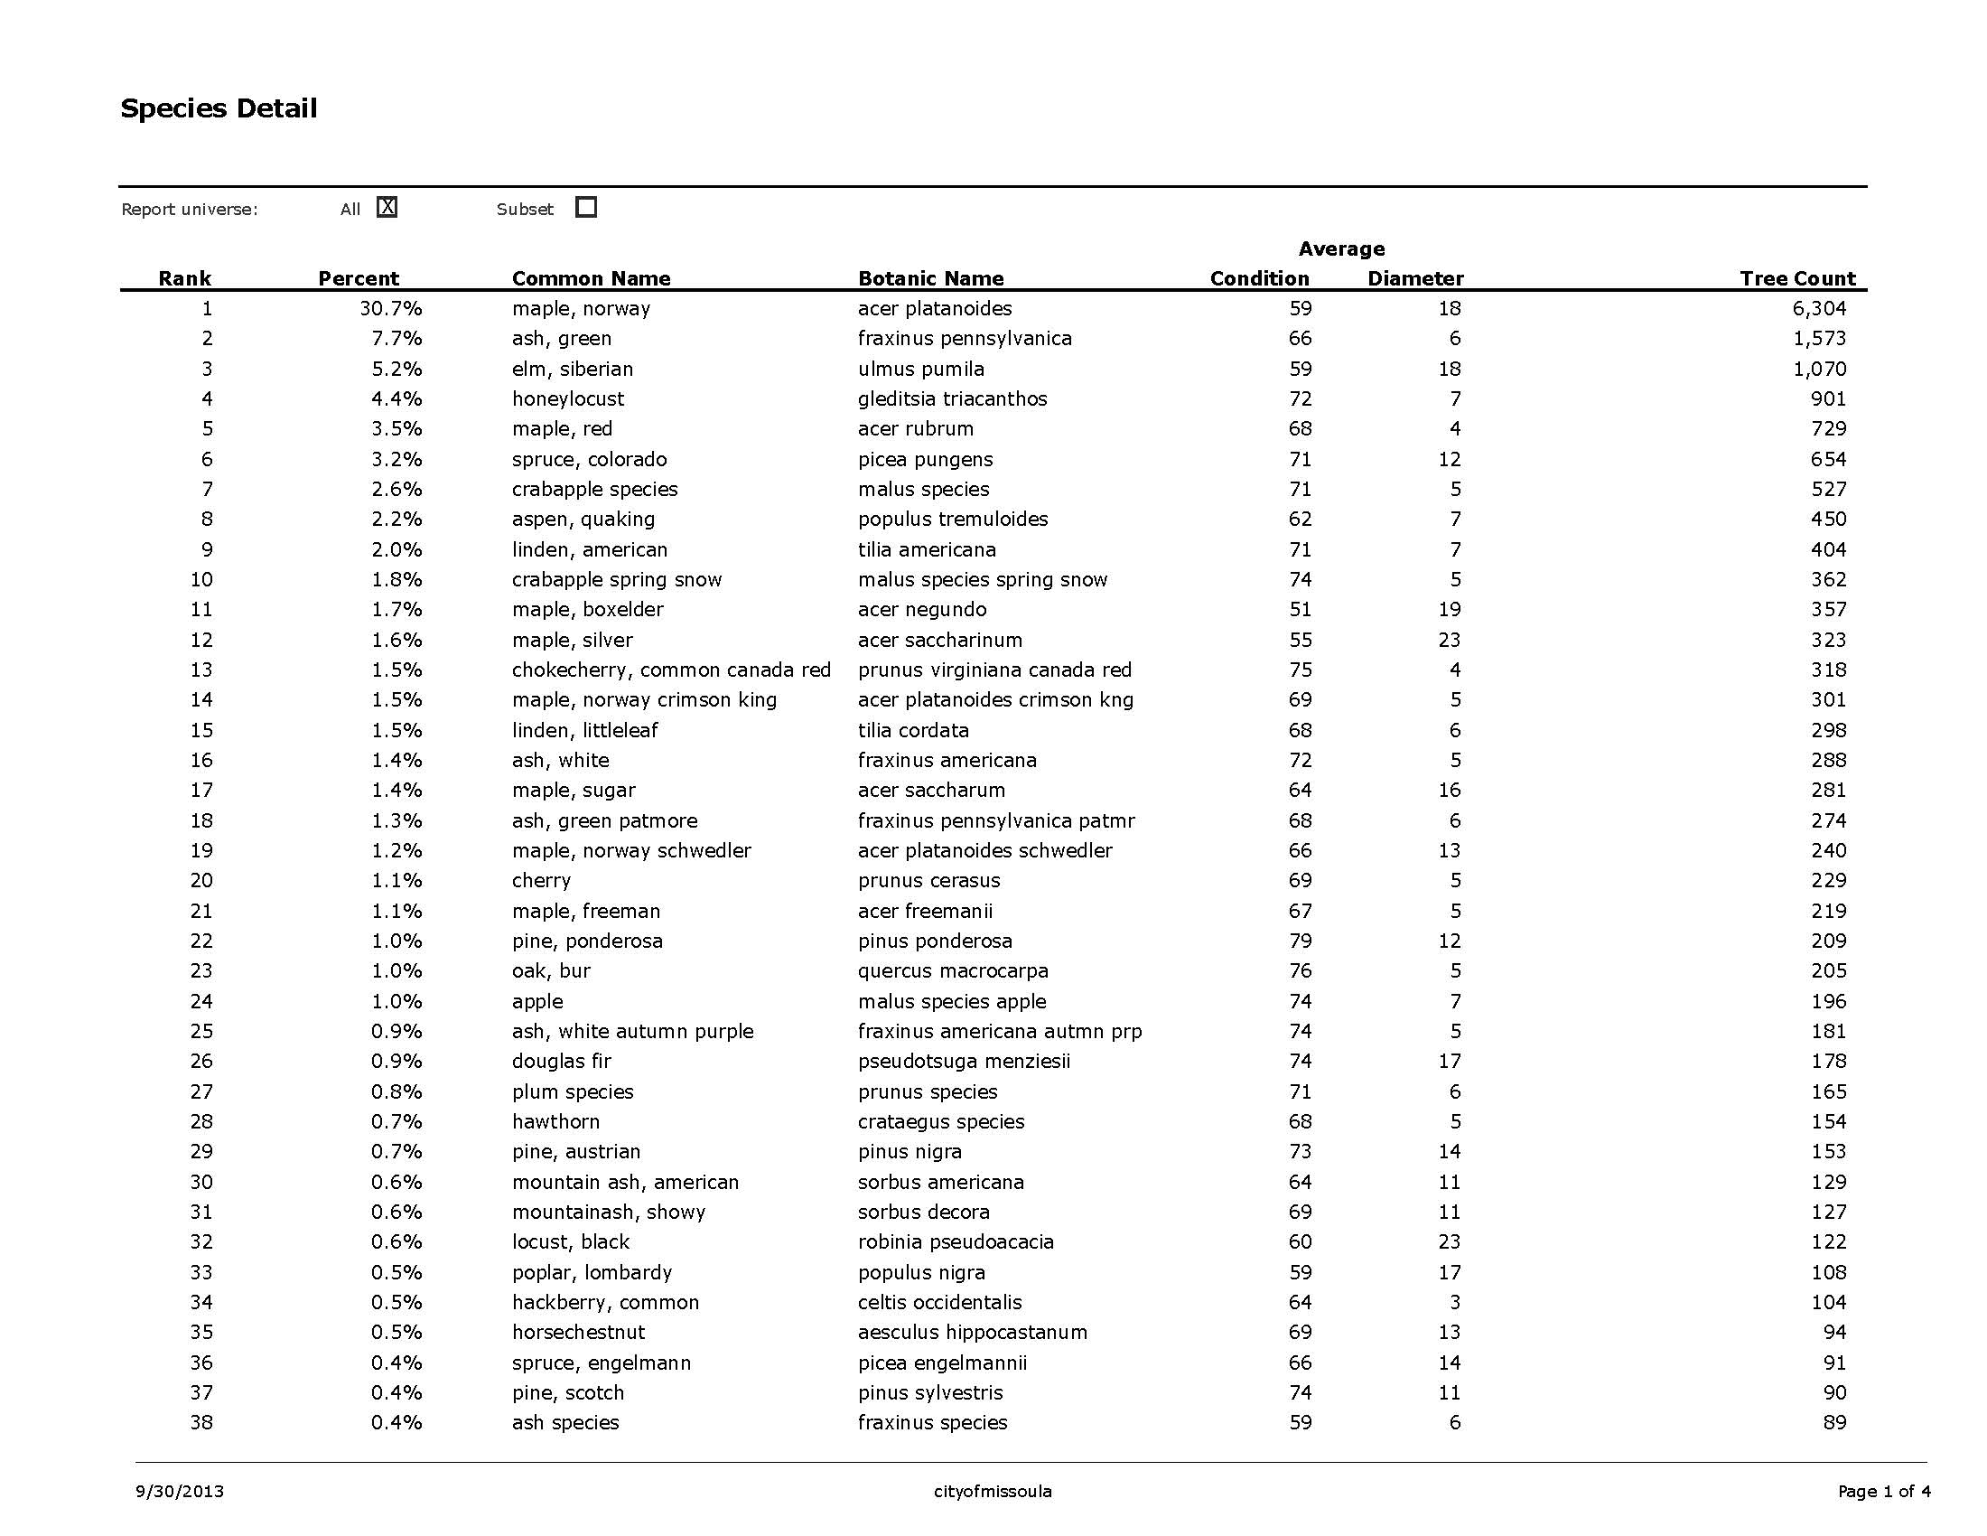

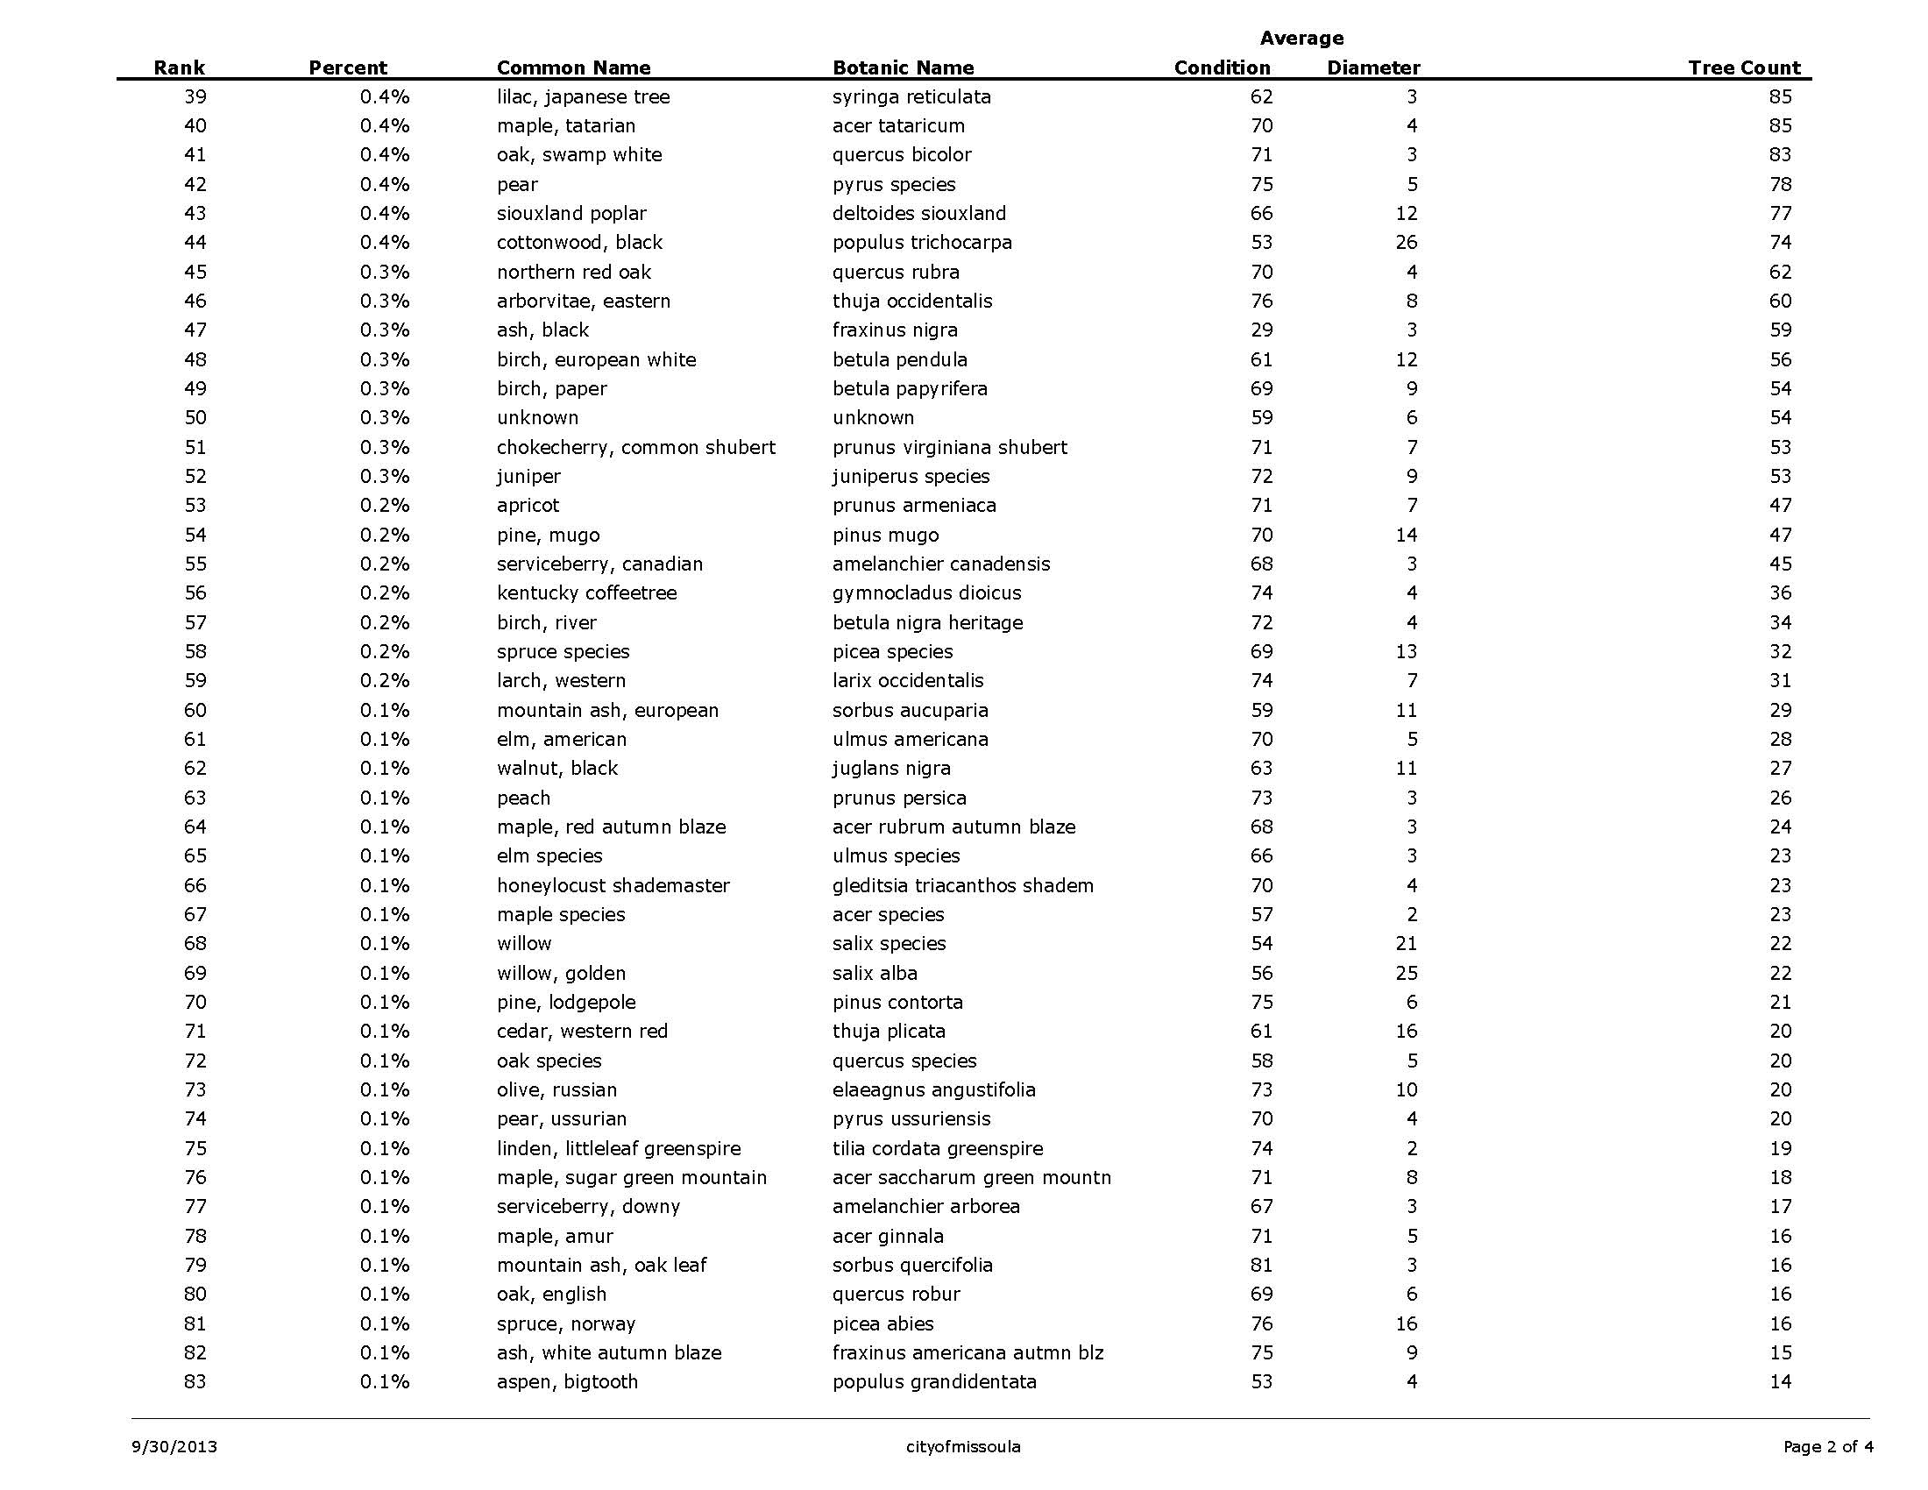

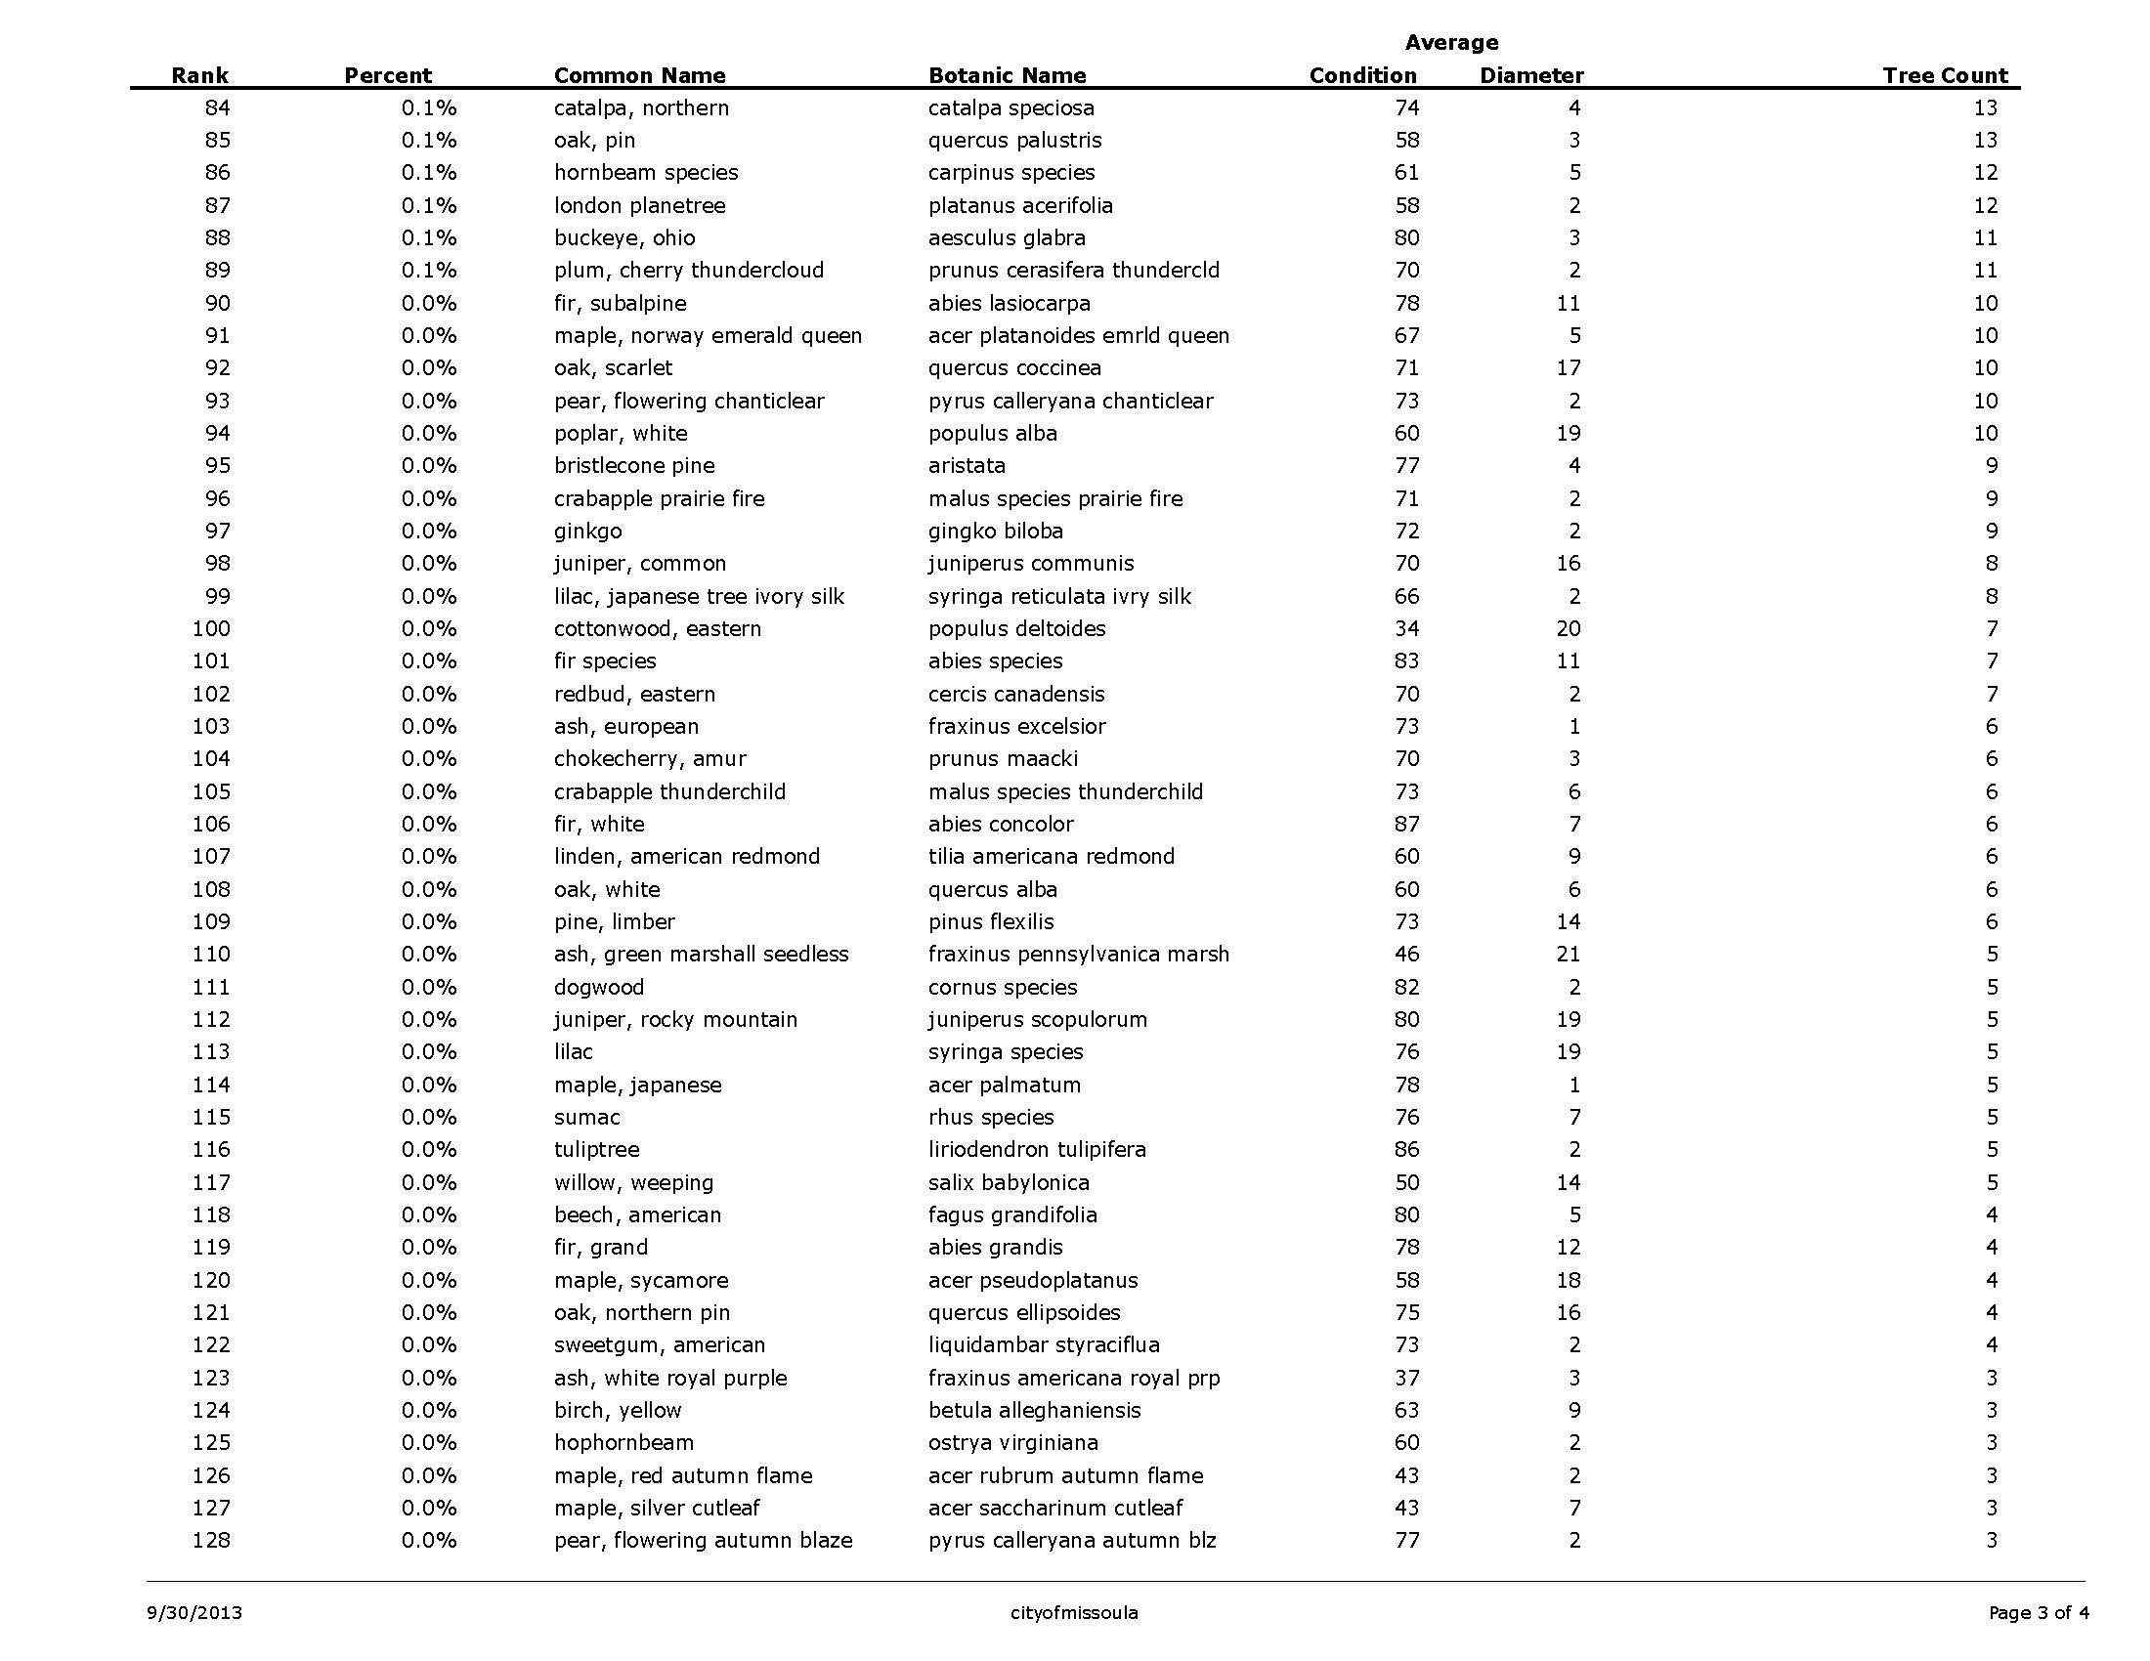

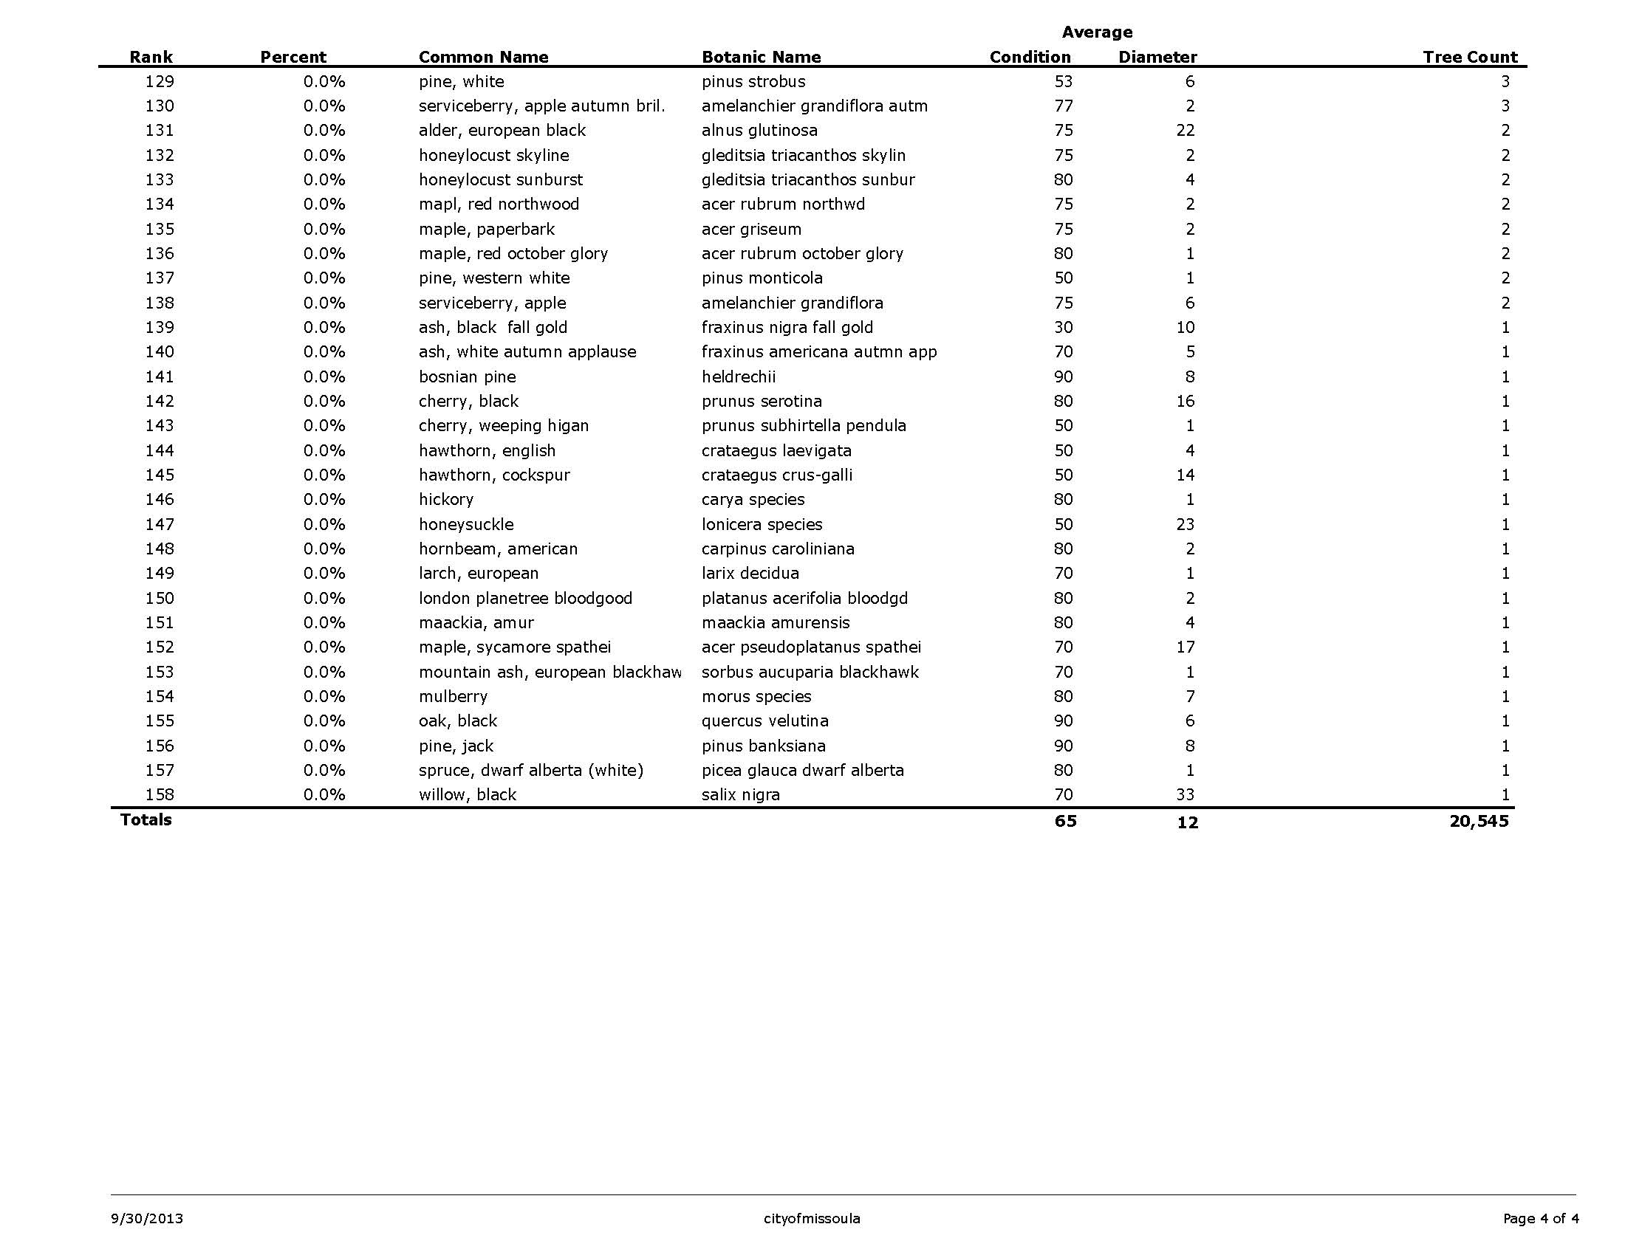

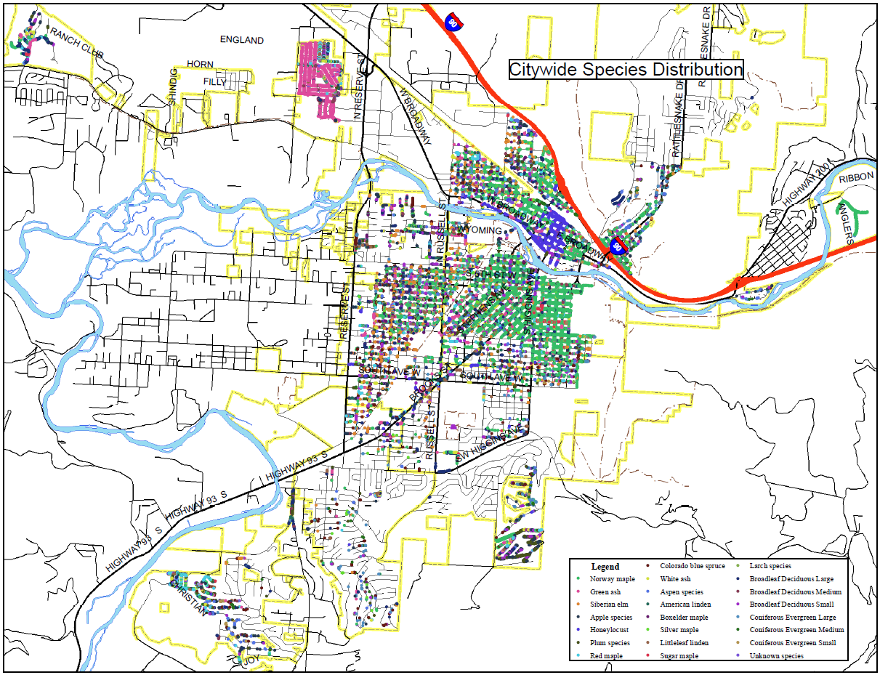

Appendix B: Results Maps

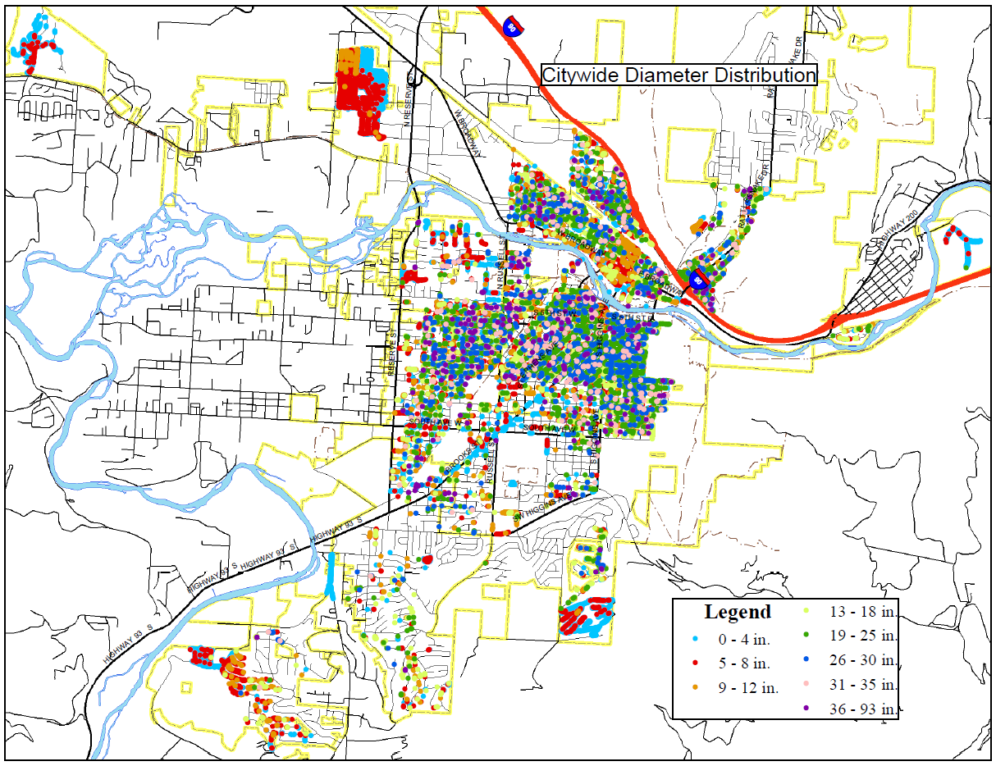

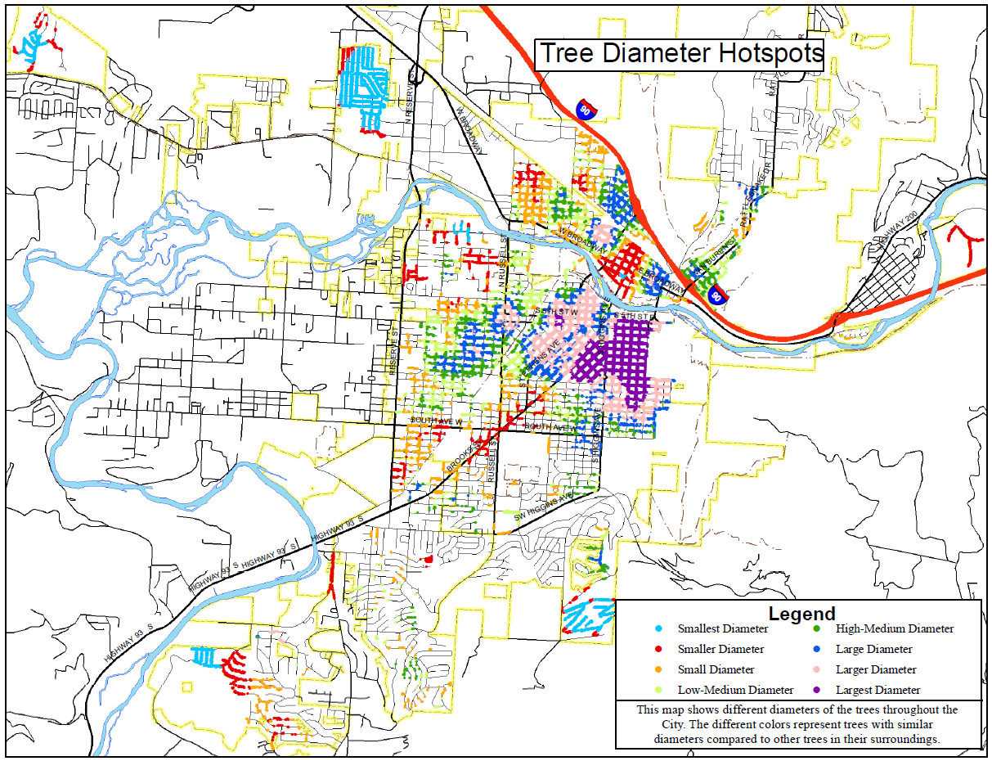

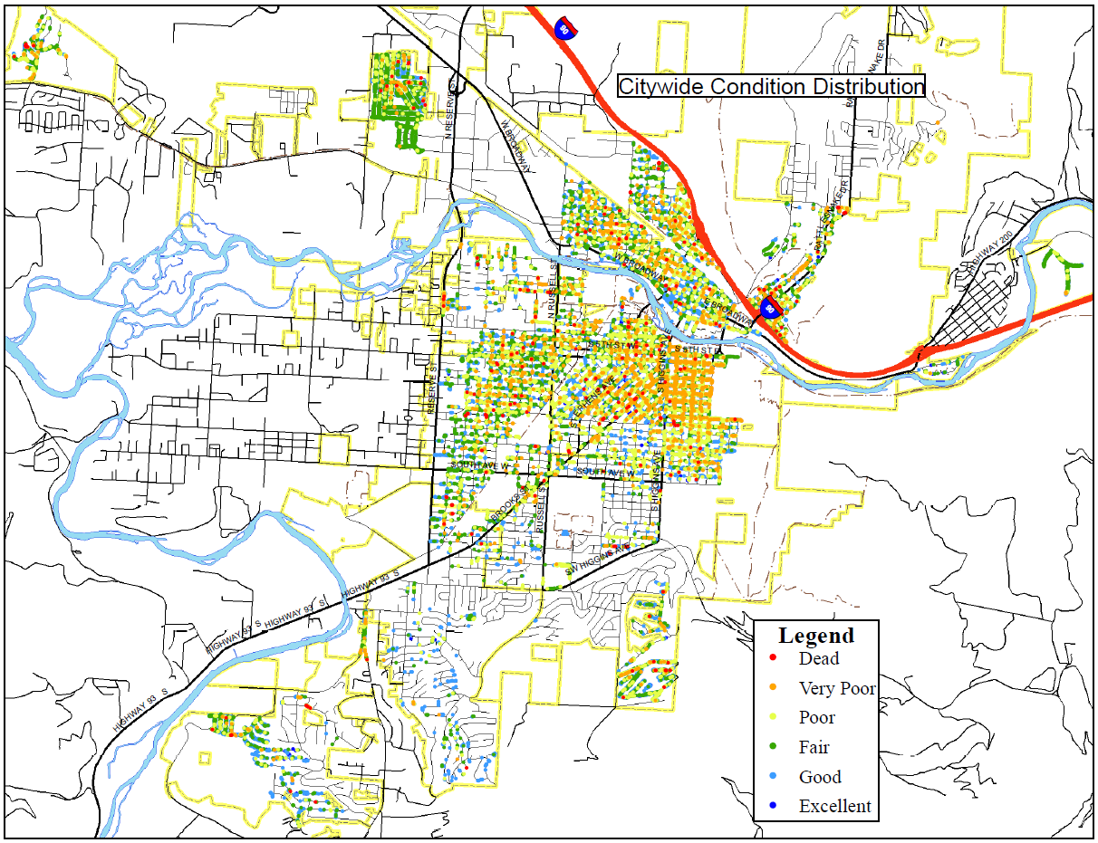

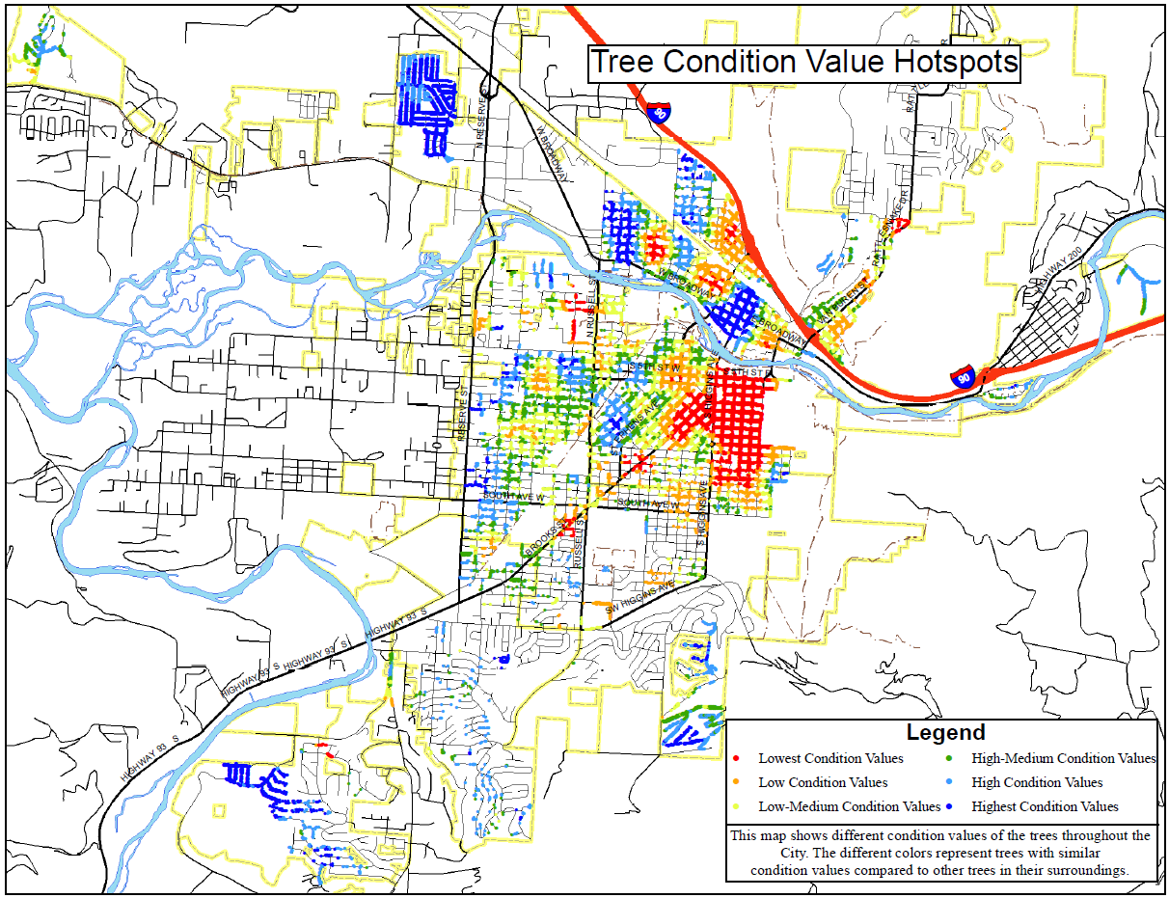

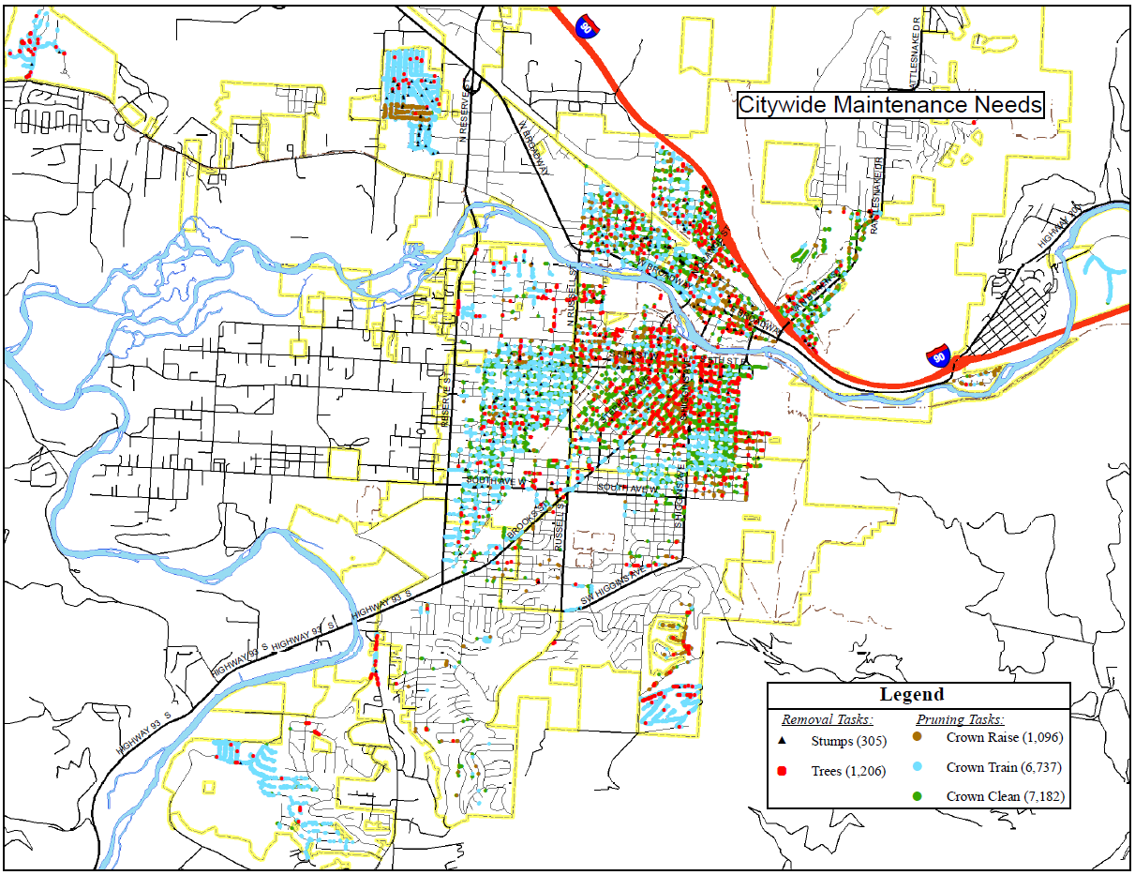

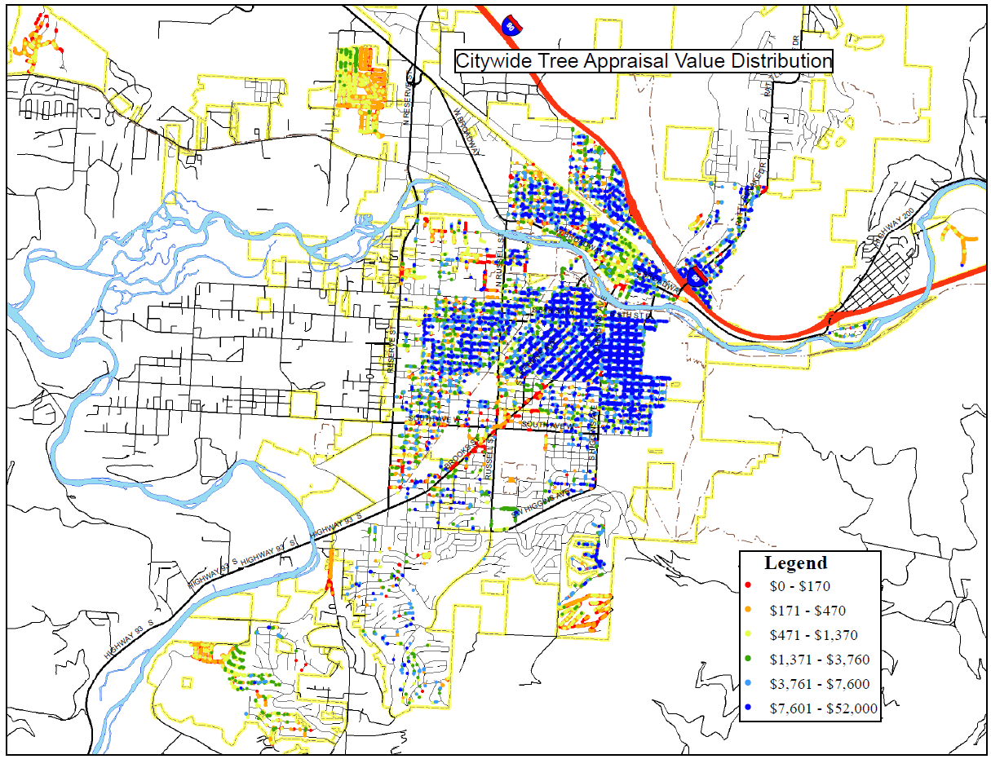

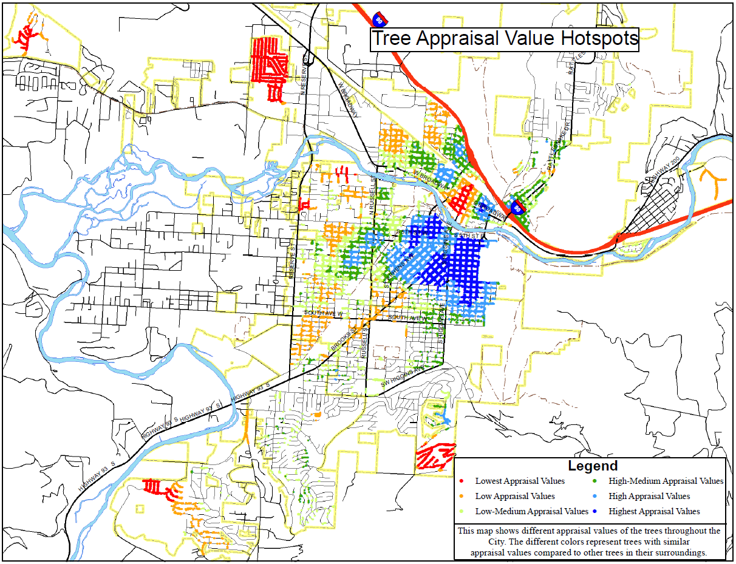

Appendix C: i-Tree Streets Benefit Lists

